**SQL Support**

For UAT1: [nonprod-staging-resource-vm0.southeastasia.cloudapp.azure.com](http://nonprod-staging-resource-vm0.southeastasia.cloudapp.azure.com)

For UAT2: [nonprod-2-resource-vm.southeastasia.cloudapp.azure.com](http://nonprod-2-resource-vm.southeastasia.cloudapp.azure.com)

            For UAT3: [nonprod-3-resource-vm0.southeastasia.cloudapp.azure.com](http://nonprod-3-resource-vm0.southeastasia.cloudapp.azure.com)

For UAT4: [nonprod-4-resource-vm0.southeastasia.cloudapp.azure.com](http://nonprod-4-resource-vm0.southeastasia.cloudapp.azure.com)

For UAT5: [nonprod-consumerlending-0.southeastasia.cloudapp.azure.com](http://nonprod-consumerlending-0.southeastasia.cloudapp.azure.com)

Orange008

Data Source=nonprod-staging-resource-vm0.southeastasia.cloudapp.azure.com;User ID=sa;Initial Catalog=ONEPAM;Provider=SQLNCLI11.1;Persist Security Info=True;Auto Translate=False;

[nonprod-staging-resource-vm0.southeastasia.cloudapp.azure.com](http://nonprod-staging-resource-vm0.southeastasia.cloudapp.azure.com)

Data Source=nonprod-2-resource-vm.southeastasia.cloudapp.azure.com;User ID=sa;Initial Catalog=ONEPAM;Provider=SQLNCLI11.1;Persist Security Info=True;Auto Translate=False;

[nonprod-2-resource-vm.southeastasia.cloudapp.azure.com](http://nonprod-2-resource-vm.southeastasia.cloudapp.azure.com)

Data Source=nonprod-3-resource-vm0.southeastasia.cloudapp.azure.com;User ID=sa;Initial Catalog=ONEPAM;Provider=SQLNCLI11.1;Persist Security Info=True;Auto Translate=False;

[nonprod-3-resource-vm0.southeastasia.cloudapp.azure.com](http://nonprod-3-resource-vm0.southeastasia.cloudapp.azure.com)

Data Source=nonprod-4-resource-vm0.southeastasia.cloudapp.azure.com;User ID=sa;Initial Catalog=ONEPAM;Provider=SQLNCLI11.1;Persist Security Info=True;Auto Translate=False;

[nonprod-4-resource-vm0.southeastasia.cloudapp.azure.com](http://nonprod-4-resource-vm0.southeastasia.cloudapp.azure.com)

Data Source=nonprod-consumerlending-0.southeastasia.cloudapp.azure.com;User ID=sa;Initial Catalog=ONEPAM;Provider=SQLNCLI11.1;Persist Security Info=True;Auto Translate=False;

[nonprod-consumerlending-0.southeastasia.cloudapp.azure.com](http://nonprod-consumerlending-0.southeastasia.cloudapp.azure.com)

MJ- <https://dev.azure.com/retailshelf/rs/_workitems/edit/110290>

<https://dev.azure.com/retailshelf/rs/_workitems/edit/111831>

<https://dev.azure.com/retailshelf/rs/_workitems/edit/110631>

<https://dev.azure.com/retailshelf/rs/_workitems/edit/109623> - synced

[UAT-WIN16DB-RW.southeastasia.cloudapp.azure.com](http://UAT-WIN16DB-RW.southeastasia.cloudapp.azure.com)

ingasia.local\dbaadmin

DBA123@BCde

Orange008

Dev - 123@BCde

super123@BCde

INGDB@only456 - exec

sekyu

UAT-WIN16DB-RW

USE Database

WIN2016DBSTAG

Initial Catalog=ReportServer;Data source=WIN2016DBSTAG

Ab0gey - Mar

Kj36Av - mark u

<https://orangesharing.com/pages/viewpage.action?spaceKey=ENG&title=SQL+Logins+and+NPA+soll> - create USER Login

INGDB@only456

begin tran

rollback - rollback to first original

commit - commit to the last commit

./remove_csv_newlines.sh

for file in `ls`; do linecount=`cat $file | wc -l`; echo "$file : $linecount"; done | awk -F ' ' -v space=' ' '$3 > 10001 {print $1 space $3}'

Altf1 sims

<https://www.red-gate.com/simple-talk/sql/ssis/ssis-basics-introducing-the-foreach-loop-container/> - for each loop ins sis

<https://www.youtube.com/watch?v=5n2v-02yzKk> - renaming ins sis

Pag SSRS Review

* Check db name to be the same on source
* Make sure there is no cross db source

Soll Matrix

<https://orangesharing.com/pages/viewpage.action?spaceKey=ENG&title=SSRS+Reporting+Dossier+-+For+SSRS+soll+request>

<https://ingthemis.service-now.com/iam?id=iam_sc_cat_item&sys_id=97ff46d50f11d300dda09acae1050e52&sysparm_category=9571099c0f7bc700be7ef55be1050e7a>

DB sync:

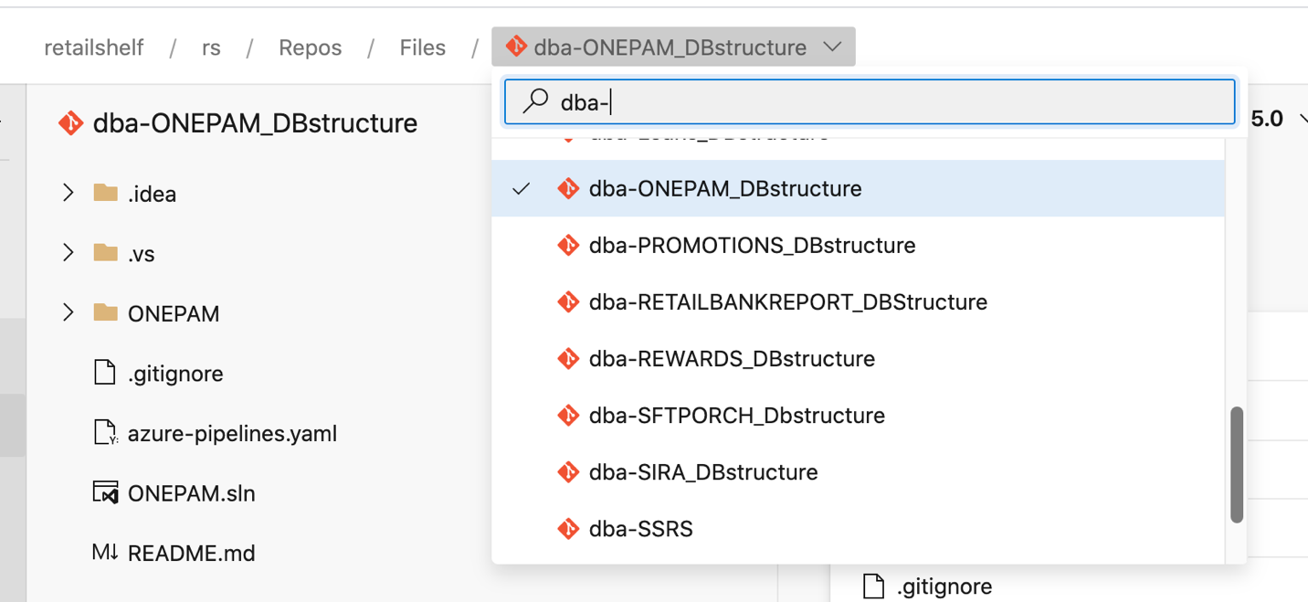

* Get the data in Repo (depending on the name of the DB) it must be in master (podlike version of scripts)

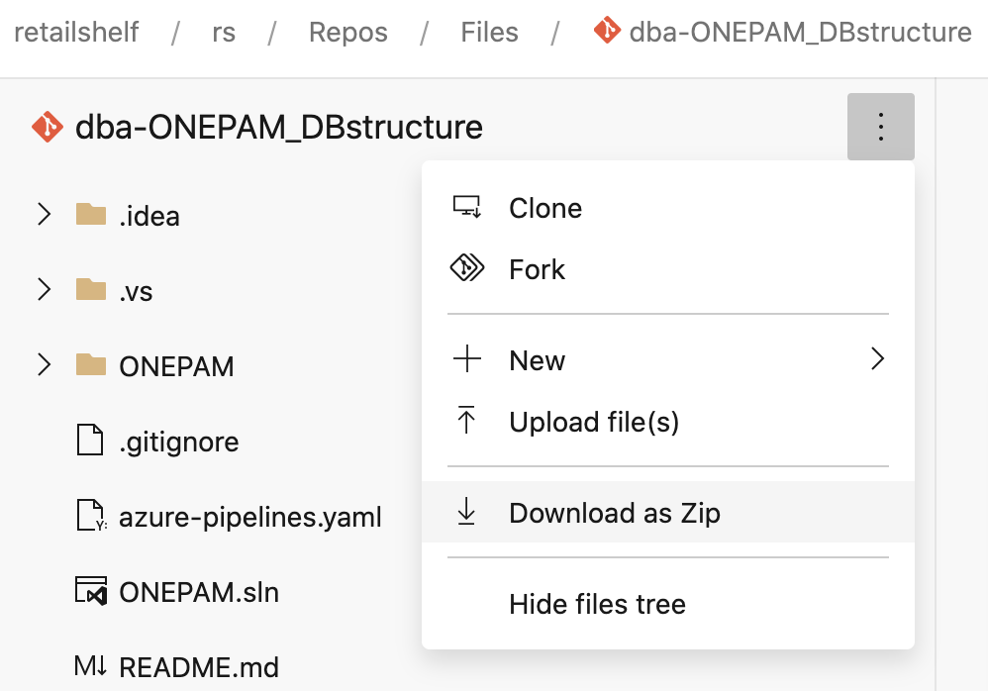

* download as Zip the db files
* go to win stag (without vpn)
* Copy the zip inside the winstag server
* Copy also CEK files for ONEPAM (it is different for others) paste inside Keys or any folder in DB files (ask to Julius)
* Open visual studio ssdt (file>new>project>Visual Basic>SSQL Server>SQL Server Database Project)
* Go to solution explorer then right click import>Script(*.sql)
* Under Select file, select multiple select then browse
* After that, right click the db and build
* Resolve every error (warning is just ok)
  + When there are same script, just comment out the duplicate script
  + Remove duplicate table under db project, just right click then exclude from project (all with _1 or duplicate)
  + Other error you may just comment out
* After that try to rebuild again until it become succeeded
* Next is to right click the db project and schema compare
* Look on the request to know the server to which we will sync
* In schema compare click option then exclude the following:
  + Application Roles
  + Database Roles
  + Permission
  + Role Membership
  + Users
* After that select target > database > connection:
  + Server name : IP address
  + Authentication: SQL Server Authentication
  + User Name: sa
  + Password: super123@BCde
* After that click compare
* For delete folder, just right click and exclude (because we don’t want to delete)
* For Change Folder (check one by one)
  + When you uncheck but there is still check , then there is a dependency
  + You can exclude “prof” tables
  + If the difference is just comment, you may exclude that
  + Column master key is excluded
* For add folder it is ok to include that
* After you review the changes, you may click update (to apply change to your target)
  + If there are error, go to error list to examine the error
  + When error will result data lost, exclude the table causing it

Deploying SSIS Package:

* Download the dtsx
* Go to win stag
* Under UAT_FINANCE_DAYEND
* Right click to “UAT” , then deploy packages
* Under Select Source, Browse (it will automatically look for packages in the directory)
* Click refresh, then ok the warning message
* Next, next, connect and deploy, then close
* Now you can configure your packages using environment I created

Creating DB:

* dba-db_structure > initialized (choose the db you want to create)
* Go to the repo of db then run the schema > tables > index
* After that tacos na (you can also use schema compare to prodlike pero add db lang ang update mo)

—Mark

SELECT TOP 10 SUBSTRING(qt.TEXT, (qs.statement_start_offset/2)+1,

((CASE qs.statement_end_offset

WHEN -1 THEN DATALENGTH(qt.TEXT)

ELSE qs.statement_end_offset

END - qs.statement_start_offset)/2)+1),

qs.execution_count,

qs.total_logical_reads, qs.last_logical_reads,

convert(money, qs.total_physical_reads/(qs.execution_count + 0.0)) as [AvgIOPhysicalReads],

convert(money, qs.total_logical_reads/(qs.execution_count + 0.0)) as [AvgIOLogicalReads],

qs.total_logical_writes, qs.last_logical_writes,

convert(money, qs.total_logical_writes/(qs.execution_count + 0.0)) as [AvgIOLogicalWrites],

qs.total_worker_time,

qs.last_worker_time,

convert(money, (qs.total_worker_time))/(qs.execution_count*1000)as [AvgCPUTime],

qs.total_elapsed_time/1000000 total_elapsed_time_in_S,

qs.last_elapsed_time/1000000 last_elapsed_time_in_S,

qs.last_execution_time,

convert(money, (qs.total_elapsed_time))/(qs.execution_count*1000)as [AvgDur],

qp.query_plan

FROM sys.dm_exec_query_stats qs

CROSS APPLY sys.dm_exec_sql_text(qs.sql_handle) qt

CROSS APPLY sys.dm_exec_query_plan(qs.plan_handle) qp

-- ORDER BY qs.total_logical_reads DESC -- logical reads

-- ORDER BY qs.total_logical_writes DESC -- logical writes

ORDER BY qs.total_worker_time DESC -- CPU time

query store setup

EXEC sp_help_revlogin

-- ********Query Store Setup********

USE [Master]

GO

ALTER DATABASE [ONEPAM]

SET QUERY_STORE (

OPERATION_MODE = READ_WRITE,

CLEANUP_POLICY = (STALE_QUERY_THRESHOLD_DAYS = 30),

DATA_FLUSH_INTERVAL_SECONDS = 3000,

MAX_STORAGE_SIZE_MB = 1000,

INTERVAL_LENGTH_MINUTES = 10,

SIZE_BASED_CLEANUP_MODE = AUTO,

QUERY_CAPTURE_MODE = AUTO,

MAX_PLANS_PER_QUERY = 1000

);

[**https://www.youtube.com/watch?v=RHnpEpk_3Ec**](https://www.youtube.com/watch?v=RHnpEpk_3Ec) **: 8min for tomorrow**

<https://www.youtube.com/watch?v=D6ooP2-KE6A> security

<https://www.youtube.com/watch?v=4uibnXs2AZc>

<https://www.youtube.com/watch?v=X7IFVFAGwuU>

For deployment

<https://www.youtube.com/watch?v=TzhtTSIOnmg> - how to create batch file

<https://www.youtube.com/watch?v=IYnkjH_dnjQ> -execute batch file

<https://www.youtube.com/watch?v=UWVc_DNj0xw> - Automate Jobs

<https://dev.azure.com/retailshelf/rs/_workitems/edit/010441>

<https://dev.azure.com/retailshelf/rs/_workitems/edit/103510/>

ADO yang nasa taas

DESKTOP-V8JLG1F

<https://www.youtube.com/watch?v=KPtcGHDdcTk> for shared folder

C2 - US currency

P2 - percentage 2 decimal

N2 - number 2 decimal

<https://dev.azure.com/retailshelf/rs/_workitems/edit/103342/> - Whitelist

IP address: 192.168.1.101

IP: 192.168.254.103

<https://mgm-poc-portal.southeastasia.cloudapp.azure.com:3000/whatismyip.php> - yung not connected ang gagamitin

112.203.22.195

112952

<https://dev.azure.com/retailshelf/rs/_build?definitionId=827&_a=summary>

Ms Juju, paapprove po ako ng pr sa SSRS yang pinaayos po ni Mark U sa ReportDB2 https://dev.azure.com/retailshelf/rs/_git/dba-ingasia-ssrs/pullrequest/55775?path=%2FINGASIA-SSRS%2FINGASIA-SSRS%2FReportServer.rds&_a=files Thank you.

ONEPAM_D_FETCH_CANDIDATE_TXN_D_BATCH

\SSISDB\ONEPAMBATCH\CIA\ONEPAM_FETCH_CANDIDATE_TXN_D_BATCH.dtsx

\SSISDB\ONEPAMBATCH\CIA\ONEPAM_FETCH_CANDIDATE_TXN_D_BATCH.dtsx

<https://www.youtube.com/watch?v=oDcf9WgSzSo> - VS to Azure DevOps

<https://dev.azure.com/retailshelf/rs/_build?definitionId=827&_a=summary> - run pipeline

<https://www.techrepublic.com/article/how-to-install-and-use-git-secret/> - git-secret

**Git**

<https://www.youtube.com/watch?v=yXT1ElMEkW8> - for reference (aside from git with mosh)

<https://www.youtube.com/watch?v=9p2d-CuVlgc&list=PLRqwX-V7Uu6ZF9C0YMKuns9sLDzK6zoiV&index=7> - series fo git

pwd - present working directory

cd dba-ingasia-ssrs - change directory to dba-ingasia-ssrs (you can just type dab then tab it will auto correct

git branch - to go to master by default

git branch dev/104261-ssrs-loan-application-report - to create and go to branch you created in devops (to create branch in local)

git checkout dev/104261-ssrs-loan-application-report - to go to the right branch (to see if your branch is up to date compared with the remote repository)

git branch - to see whether you are in master or other branch

git pull - see the tracking information (to see and copy new items in remote to local branch)

git branch --set-upstream-to=origin/dev/104261-ssrs-loan-application-report dev/104261-ssrs-loan-application-report - to set tracking information from azure to local repository or set up to track remote branch (on my own understanding)

git branch -vv - to see what branches are tracked and which are not (according to google)

git status - to see the status

git diff INGASIA-SSRS/INGASIA-SSRS/INGASIA-SSRS.rptproj - to see what are difference between original and chaged INGASIA-SSRS/INGASIA-SSRS/INGASIA-SSRS.rptproj (+ added - deleted)

git diff INGASIA-SSRS/configs/config.json - same thing with the above but this time to INGASIA-SSRS/configs/config.json

git status - to see if your branch is up to date

git add LOAN_APPLICATION.rdl INGASIA-SSRS/configs/config.json INGASIA-SSRS/INGASIA-SSRS/INGASIA-SSRS.rptproj - to add the 3 separated by space to the staging area

git status - to see again if the status is updated after adding

git branch - to see if you are in the right branch

git commit -m "[104261] add LOAN_APPLICATION RDL " - to commit changes in staging area and put a message based on the format given

git push - to push changes you committed in the web ( pushes your code to remote repository in azure devops)

cp - same as mv move as per google

mv LOAN_APPLICATION.rdl INGASIA-SSRS/INGASIA-SSRS - move LOAN_APPLICATION.rdl inside the INGASIA-SSRS/INGASIA-SSRS folder

git status - to see what happen to files you moved

git rm LOAN_APPLICATION.rdl - to remove what is deleted in staging area

git add INGASIA-SSRS/INGASIA-SSRS/LOAN_APPLICATION.rdl - to add changes in staging area

git status - to verify again the status

git commit -m "[104261] move LOAN_APPLICATION " - commit again the changes with meaningful description according to prescribed format

git push - to push again the changes in azure

Well Done!

Create first a support branch that you will use in git

Update first the config.json and INGASIA-SSRS.rptproj in text editor

To remove file:

Git rm <file>

Git commit

Git push

Git checkout master - to make the same to master yung nasa local

Git pull origin master - pull from master the changes if ever

Git checkout -b

rm - to remove files to working directory

git rm - to remove files in both working directory and staging area

git checkout -- <file>..." to discard changes in working directory

git merge - to merge branch to master

git pull -  without any arguments defaults to currently checked out branch and the remote repository it is set to track.

git push - it is best to use git push <remote> <branch>

When there are changes:

add>commit>push

New user of git without existing local repo:

clone>git ignore>

update repo:

pull

git merge --abort ; para masala lahat ng changes

—creating release based on master, as similar if based on task branch

checkout master ako sa git then nag git checkout -b release

Last login: Mon Nov 9 16:35:44 on ttys001

ww80xc@APM3LC02CK2HBMD6R ~ % s

zsh: command not found: s

ww80xc@APM3LC02CK2HBMD6R ~ % ls

Applications Movies dba-ingasia-ssrs

Desktop Music devops-git-secrets

Documents Pictures readme.txt

Downloads Public

Library VirtualBox VMs

ww80xc@APM3LC02CK2HBMD6R ~ % pdw

zsh: command not found: pdw

ww80xc@APM3LC02CK2HBMD6R ~ % pwd

/Users/ww80xc

ww80xc@APM3LC02CK2HBMD6R ~ % cd dba-ingasia-ssrs

ww80xc@APM3LC02CK2HBMD6R dba-ingasia-ssrs % git branch

* master

ww80xc@APM3LC02CK2HBMD6R dba-ingasia-ssrs % git branch dev/104261-ssrs-loan-application-report

ww80xc@APM3LC02CK2HBMD6R dba-ingasia-ssrs % git checkout dev/104261-ssrs-loan-application-report

M INGASIA-SSRS/INGASIA-SSRS/INGASIA-SSRS.rptproj

M INGASIA-SSRS/configs/config.json

Switched to branch 'dev/104261-ssrs-loan-application-report'

ww80xc@APM3LC02CK2HBMD6R dba-ingasia-ssrs % git branch

* dev/104261-ssrs-loan-application-report

master

ww80xc@APM3LC02CK2HBMD6R dba-ingasia-ssrs % git pull

remote: Azure Repos

remote: We noticed you're using an older version of Git. For the best experience, upgrade to a newer version.

remote: Found 183 objects to send. (7 ms)

Receiving objects: 100% (183/183), 47.65 KiB | 6.81 MiB/s, done.

Resolving deltas: 100% (78/78), completed with 22 local objects.

From https://dev.azure.com/retailshelf/rs/_git/dba-ingasia-ssrs

* [new branch] dev/104261-ssrs-loan-application-report -> origin/dev/104261-ssrs-loan-application-report

* [new branch] dev/104286-loan-application-audit-trail -> origin/dev/104286-loan-application-audit-trail

cad76e2..f596368 dev/104287-approved-loans -> origin/dev/104287-approved-loans

* [new branch] dev/104892-CASA-Funnel -> origin/dev/104892-CASA-Funnel

* [new branch] pbi/100736-create-cif-account-number-report-v5 -> origin/pbi/100736-create-cif-account-number-report-v5

247cfe3..9e6a71d pbi/100873-move-follow-up-reports-from-operations-to-ibss-operations-reports-folder -> origin/pbi/100873-move-follow-up-reports-from-operations-to-ibss-operations-reports-folder

* [new branch] pbi/101348-Add_columns_to_TTX_report -> origin/pbi/101348-Add_columns_to_TTX_report

* [new branch] pbi/104945_cashback_crediting -> origin/pbi/104945_cashback_crediting

ceb9eea..ab2a5b1 release/102320.RELEASE.BI.2020.50.0 -> origin/release/102320.RELEASE.BI.2020.50.0

* [new branch] release/104892.RELEASE.BI.2020.44.0 -> origin/release/104892.RELEASE.BI.2020.44.0

* [new branch] release/RELEASE.BI.RS.2020.10.15-102752-v3 -> origin/release/RELEASE.BI.RS.2020.10.15-102752-v3

* [new branch] release/RELEASE.BI.RS.2020.11.09-101476 -> origin/release/RELEASE.BI.RS.2020.11.09-101476

* [new branch] release/RELEASE.SSRS.TTX.2020.11.9 -> origin/release/RELEASE.SSRS.TTX.2020.11.9

bf1763c..dded5db task/100791-create-cif-account-number -> origin/task/100791-create-cif-account-number

* [new branch] task/101348-Add_columns_to_TTX_report -> origin/task/101348-Add_columns_to_TTX_report

bbb07b2..638f9a0 task/102340-change-follow-up-reports-to-ibss-operations-report-folder -> origin/task/102340-change-follow-up-reports-to-ibss-operations-report-folder

* [new branch] task/105044_cashback_crediting -> origin/task/105044_cashback_crediting

2d252a4..6faec70 task/97853-create-new-ssrs-report -> origin/task/97853-create-new-ssrs-report

There is no tracking information for the current branch.

Please specify which branch you want to merge with.

See git-pull(1) for details.

git pull <remote> <branch>

If you wish to set tracking information for this branch you can do so with:

git branch --set-upstream-to=origin/<branch> dev/104261-ssrs-loan-application-report

ww80xc@APM3LC02CK2HBMD6R dba-ingasia-ssrs % git branch --set-upstream-to=origin/dev/104261-ssrs-loan-application-report dev/104261-ssrs-loan-application-report

Branch 'dev/104261-ssrs-loan-application-report' set up to track remote branch 'dev/104261-ssrs-loan-application-report' from 'origin'.

ww80xc@APM3LC02CK2HBMD6R dba-ingasia-ssrs % git branch -vv

* dev/104261-ssrs-loan-application-report cbef416 [origin/dev/104261-ssrs-loan-application-report] Merged PR 36055: Post Credit and Notification Report v2

master cbef416 [origin/master] Merged PR 36055: Post Credit and Notification Report v2

ww80xc@APM3LC02CK2HBMD6R dba-ingasia-ssrs % git status

On branch dev/104261-ssrs-loan-application-report

Your branch is up to date with 'origin/dev/104261-ssrs-loan-application-report'.

Changes not staged for commit:

(use "git add <file>..." to update what will be committed)

(use "git checkout -- <file>..." to discard changes in working directory)

modified: INGASIA-SSRS/INGASIA-SSRS/INGASIA-SSRS.rptproj

modified: INGASIA-SSRS/configs/config.json

Untracked files:

(use "git add <file>..." to include in what will be committed)

LOAN_APPLICATION.rdl

no changes added to commit (use "git add" and/or "git commit -a")

ww80xc@APM3LC02CK2HBMD6R dba-ingasia-ssrs % git diff INGASIA-SSRS/INGASIA-SSRS/INGASIA-SSRS.rptproj

**diff --git a/INGASIA-SSRS/INGASIA-SSRS/INGASIA-SSRS.rptproj b/INGASIA-SSRS/INGASIA-SSRS/INGASIA-SSRS.rptproj**

**index 7e94e84..aea03c0 100644**

**--- a/INGASIA-SSRS/INGASIA-SSRS/INGASIA-SSRS.rptproj**

**+++ b/INGASIA-SSRS/INGASIA-SSRS/INGASIA-SSRS.rptproj**

@@ -151,6 +151,7 @@

<Report Include="MOBILE CHECK.rdl" />

<Report Include="DB Daily Report FriendsAndFamily.rdl" />

<Report Include="CARD_DETAILS.rdl" />

+ <Report Include="LOAN_APPLICATION.rdl" />

</ItemGroup>

ww80xc@APM3LC02CK2HBMD6R dba-ingasia-ssrs % git diff INGASIA-SSRS/configs/config.json

**diff --git a/INGASIA-SSRS/configs/config.json b/INGASIA-SSRS/configs/config.json**

**index 80c85e9..2272dc1 100644**

**--- a/INGASIA-SSRS/configs/config.json**

**+++ b/INGASIA-SSRS/configs/config.json**

@@ -51,7 +51,7 @@

]

}

]

- },

+ }

{

"Name": "",

"Folders": [

@@ -60,28 +60,12 @@

"Reports": [

{

- "Name": "CI_NOTIFICATIONS",

- "FileName": "CI_NOTIFICATIONS.rdl"

- }

- ]

- },

- {

- "Name": "INTEREST OFFER REPORTS",

- "Reports": [

- {

- "Name": "NET CASH CREDIT",

- "FileName": "NET CASH CREDIT.rdl"

- },

- {

- "Name": "POST CREDIT REPORT",

- "FileName": "POST CREDIT.rdl"

- },

- {

- "Name": "POST CREDIT NOTIFICATION REPORT",

- "FileName": "POST CREDIT NOTIFICATION.rdl"

+ "Name": "LOAN_APPLICATION",

+ "FileName": "LOAN_APPLICATION.rdl"

ww80xc@APM3LC02CK2HBMD6R dba-ingasia-ssrs % git status

On branch dev/104261-ssrs-loan-application-report

Your branch is up to date with 'origin/dev/104261-ssrs-loan-application-report'.

Changes not staged for commit:

(use "git add <file>..." to update what will be committed)

(use "git checkout -- <file>..." to discard changes in working directory)

modified: INGASIA-SSRS/INGASIA-SSRS/INGASIA-SSRS.rptproj

modified: INGASIA-SSRS/configs/config.json

Untracked files:

(use "git add <file>..." to include in what will be committed)

LOAN_APPLICATION.rdl

no changes added to commit (use "git add" and/or "git commit -a")

ww80xc@APM3LC02CK2HBMD6R dba-ingasia-ssrs % git add LOAN_APPLICATION.rdl INGASIA-SSRS/configs/config.json INGASIA-SSRS/INGASIA-SSRS/INGASIA-SSRS.rptproj

ww80xc@APM3LC02CK2HBMD6R dba-ingasia-ssrs % git status

On branch dev/104261-ssrs-loan-application-report

Your branch is up to date with 'origin/dev/104261-ssrs-loan-application-report'.

Changes to be committed:

(use "git reset HEAD <file>..." to unstage)

modified: INGASIA-SSRS/INGASIA-SSRS/INGASIA-SSRS.rptproj

modified: INGASIA-SSRS/configs/config.json

new file: LOAN_APPLICATION.rdl

ww80xc@APM3LC02CK2HBMD6R dba-ingasia-ssrs % git branch

* dev/104261-ssrs-loan-application-report

master

ww80xc@APM3LC02CK2HBMD6R dba-ingasia-ssrs % git commit -m "[104261] add LOAN_APPLICATION RDL "

[dev/104261-ssrs-loan-application-report 09885b8] [104261] add LOAN_APPLICATION RDL

3 files changed, 1540 insertions(+), 20 deletions(-)

create mode 100644 LOAN_APPLICATION.rdl

ww80xc@APM3LC02CK2HBMD6R dba-ingasia-ssrs % git push

Counting objects: 8, done.

Delta compression using up to 12 threads.

Compressing objects: 100% (7/7), done.

Writing objects: 100% (8/8), 4.38 KiB | 2.19 MiB/s, done.

Total 8 (delta 3), reused 0 (delta 0)

remote: Analyzing objects... (8/8) (37 ms)

remote: Storing packfile... done (41 ms)

remote: Storing index... done (45 ms)

remote: We noticed you're using an older version of Git. For the best experience, upgrade to a newer version.

To https://dev.azure.com/retailshelf/rs/_git/dba-ingasia-ssrs

cbef416..09885b8 dev/104261-ssrs-loan-application-report -> dev/104261-ssrs-loan-application-report

ww80xc@APM3LC02CK2HBMD6R dba-ingasia-ssrs % cp

usage: cp [-R [-H | -L | -P]] [-fi | -n] [-apvXc] source_file target_file

cp [-R [-H | -L | -P]] [-fi | -n] [-apvXc] source_file ... target_directory

ww80xc@APM3LC02CK2HBMD6R dba-ingasia-ssrs % mv LOAN_APPLICATION.rdl INGASIA-SSRS/INGASIA-SSRS

ww80xc@APM3LC02CK2HBMD6R dba-ingasia-ssrs % git status

On branch dev/104261-ssrs-loan-application-report

Your branch is up to date with 'origin/dev/104261-ssrs-loan-application-report'.

Changes not staged for commit:

(use "git add/rm <file>..." to update what will be committed)

(use "git checkout -- <file>..." to discard changes in working directory)

deleted: LOAN_APPLICATION.rdl

Untracked files:

(use "git add <file>..." to include in what will be committed)

INGASIA-SSRS/INGASIA-SSRS/LOAN_APPLICATION.rdl

no changes added to commit (use "git add" and/or "git commit -a")

ww80xc@APM3LC02CK2HBMD6R dba-ingasia-ssrs % git rm LOAN_APPLICATION.rdl

rm 'LOAN_APPLICATION.rdl'

ww80xc@APM3LC02CK2HBMD6R dba-ingasia-ssrs % git add INGASIA-SSRS/INGASIA-SSRS/LOAN_APPLICATION.rdl

ww80xc@APM3LC02CK2HBMD6R dba-ingasia-ssrs % git status

On branch dev/104261-ssrs-loan-application-report

Your branch is up to date with 'origin/dev/104261-ssrs-loan-application-report'.

Changes to be committed:

(use "git reset HEAD <file>..." to unstage)

renamed: LOAN_APPLICATION.rdl -> INGASIA-SSRS/INGASIA-SSRS/LOAN_APPLICATION.rdl

ww80xc@APM3LC02CK2HBMD6R dba-ingasia-ssrs % git commit -m "[104261] move LOAN_APPLICATION "

[dev/104261-ssrs-loan-application-report 9a70ad6] [104261] move LOAN_APPLICATION

1 file changed, 0 insertions(+), 0 deletions(-)

rename LOAN_APPLICATION.rdl => INGASIA-SSRS/INGASIA-SSRS/LOAN_APPLICATION.rdl (100%)

ww80xc@APM3LC02CK2HBMD6R dba-ingasia-ssrs % git push

Counting objects: 4, done.

Delta compression using up to 12 threads.

Compressing objects: 100% (4/4), done.

Writing objects: 100% (4/4), 486 bytes | 486.00 KiB/s, done.

Total 4 (delta 2), reused 0 (delta 0)

remote: Analyzing objects... (4/4) (86 ms)

remote: Storing packfile... done (54 ms)

remote: Storing index... done (65 ms)

remote: We noticed you're using an older version of Git. For the best experience, upgrade to a newer version.

To https://dev.azure.com/retailshelf/rs/_git/dba-ingasia-ssrs

09885b8..9a70ad6 dev/104261-ssrs-loan-application-report -> dev/104261-ssrs-loan-application-report

ww80xc@APM3LC02CK2HBMD6R dba-ingasia-ssrs %

**Install Git**

* I install using **binary installer**
* Right click package and continue (read also the “read me”
* export PATH="/usr/local/bin:$PATH" (when errors occurs)

To change Name:

git config user.name “Mark Joseph Lupango”

git config user.name

Git Secret - need to have secure ssh public key in azure devOps

Plugin in Visual Studio - wala pa

/bin/bash -c "$(curl -fsSL https://raw.githubusercontent.com/Homebrew/install/master/install.sh)"

<https://retailshelf@dev.azure.com/retailshelf/rs/_git/dba-ingasia-ssrs>

<https://retailshelf@dev.azure.com/retailshelf/rs/_git/dba-ingasia-ssrs>

5nakiimism4g5zdyqge4iephiyhjwhxqltg7kaphvmh7ta2a3cbq

User name: mark.joseph.lupango

pw: 7mic7ptjnn52fkr5nvr7mvce2f2365spv5uij7y44yjtw4c4jfba

7mic7ptjnn52fkr5nvr7mvce2f2365spv5uij7y44yjtw4c4jfba

Ssh - git@ssh.dev.azure.com:v3/retailshelf/rs/dba-ingasia-ssrs

Pw - 97:70:33:82:fd:29:3a:73:39:af:6a:07:ad:f8:80:49 (RSA)

ohD8VZEXGWo6Ez8GSEJQ9WpafgLFsOfLOtGGQCQo6Og (RSA)

Question

* Unable to access : git clone
* Visual Studio (SSDT) or IDE?
* Cannot connect to devTest/UAT DB

Di ka makakaconect sa database pag naka VPN

SSH fingerprint:

SHA256:cKRI5APJxSqJeYCCSIQUVM2alvz+IZoQBhdmNjX865s ww80xc@APM3LC02CK2HBMD6R

Whitelist in Pipeline: <https://dev.azure.com/retailshelf/rs/_wiki/wikis/rs.wiki/607/Guidelines-for-NSG-Whitelist-Request>

SSH Key: <https://docs.microsoft.com/en-us/azure/devops/repos/git/use-ssh-keys-to-authenticate?view=azure-devops>

<https://dev.azure.com/retailshelf/rs/_build/results?buildId=169359&view=results> - run pipelines

<https://dev.azure.com/retailshelf/rs/_build?definitionId=827>

Command line in Mac terminal:

* “ls” then “open dba-ingasia-ssrs”

<https://dev.azure.com/retailshelf/rs/_git/dba-ingasia-ssrs> - creating new branch

**Loan Application**

* INCOME_VERIFICATION_STATUS- INCOME_VEERIFICATION (Ins)
* PURPOSE (Purpose ID lang)
* REPAYMENT_DATE - repayment day lang

Title Arial 14

Head Arial 12, Silver BG, Fixed (Under Static, Repeat mo)

Data Arial 10

Task -> Pbi/Tbi -> Release -> Master

<https://docs.microsoft.com/en-us/azure/devops/boards/work-items/guidance/scrum-process-workflow?view=azure-devops> - for PBI notes

* There is already Features
* Create PBI ticket (Product Backlogs Item), change to “build” and assign it to yourself

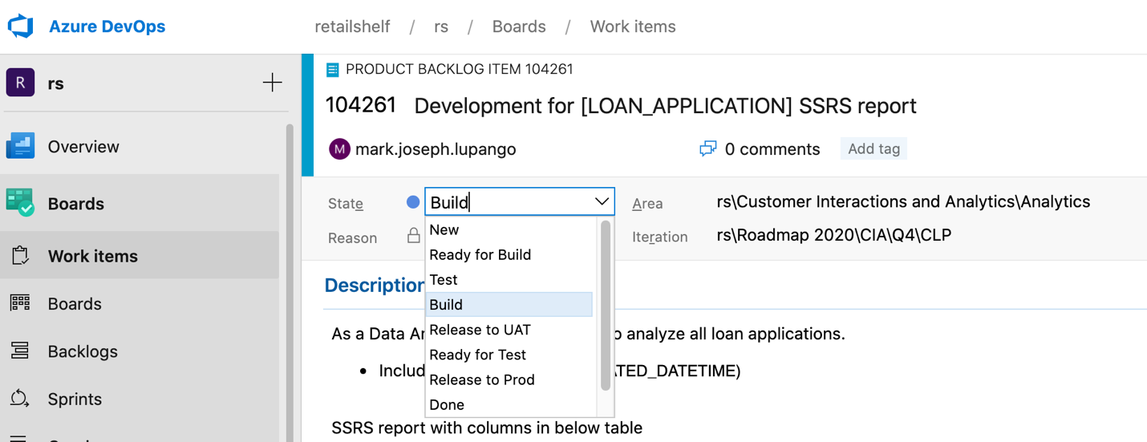

* Create release ticket

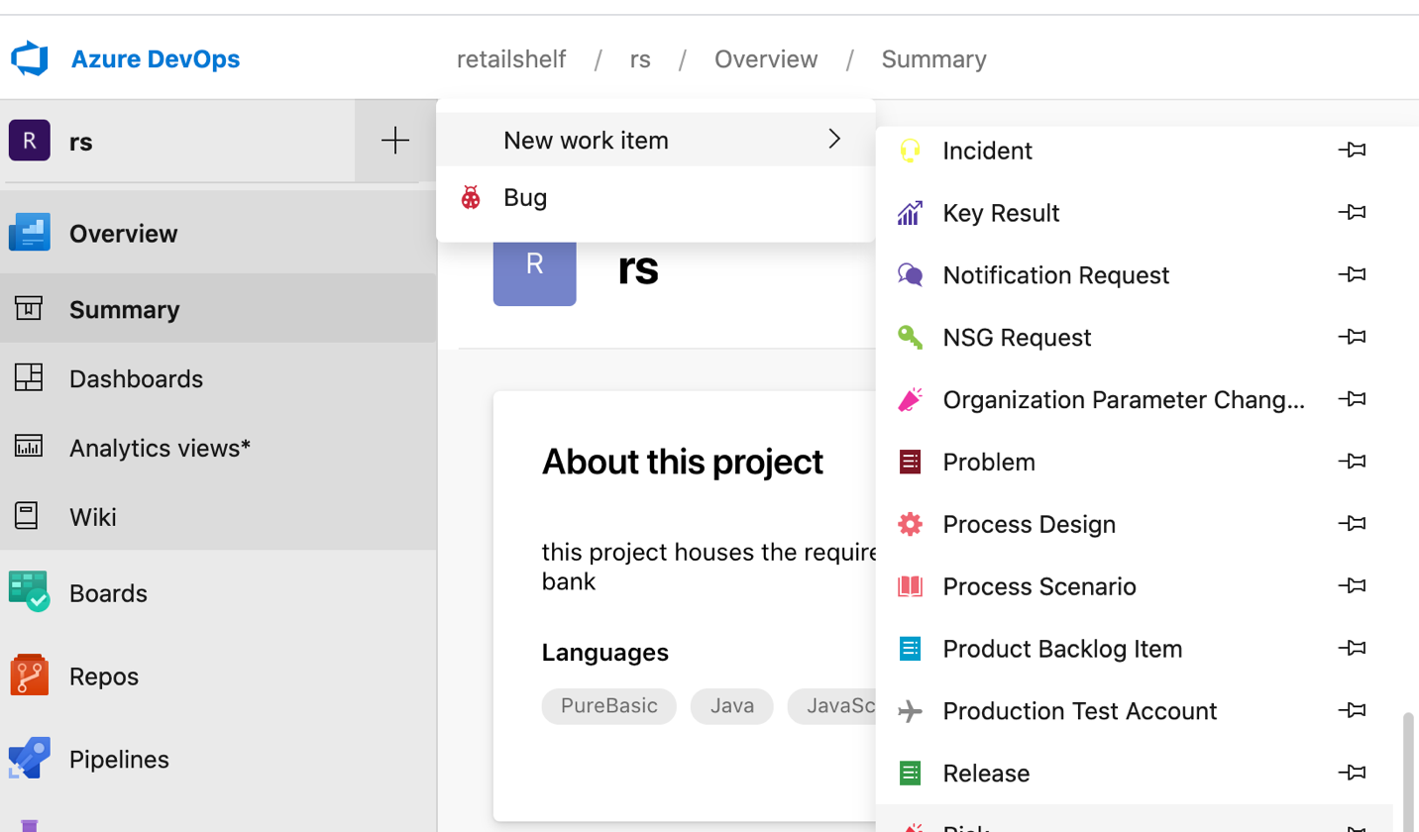

* Create new branch according to the format (Ex. Dev/123456-loan-aaplication”), create in in the repos

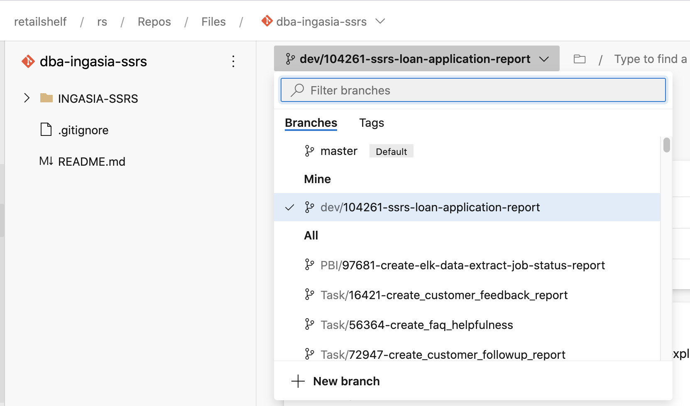

* Ready to Develop SSRS Reports, open the solution and update the DB and DateSet you need
* Update the config.json and INGASIA-SSRS.rptproj in text editor

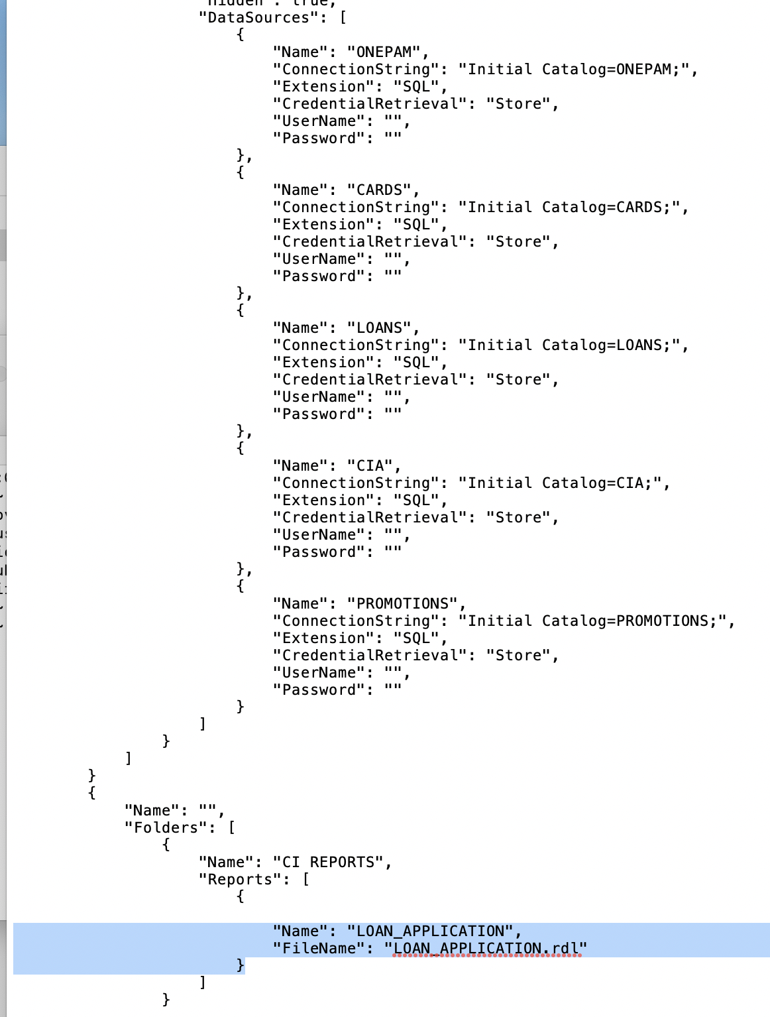

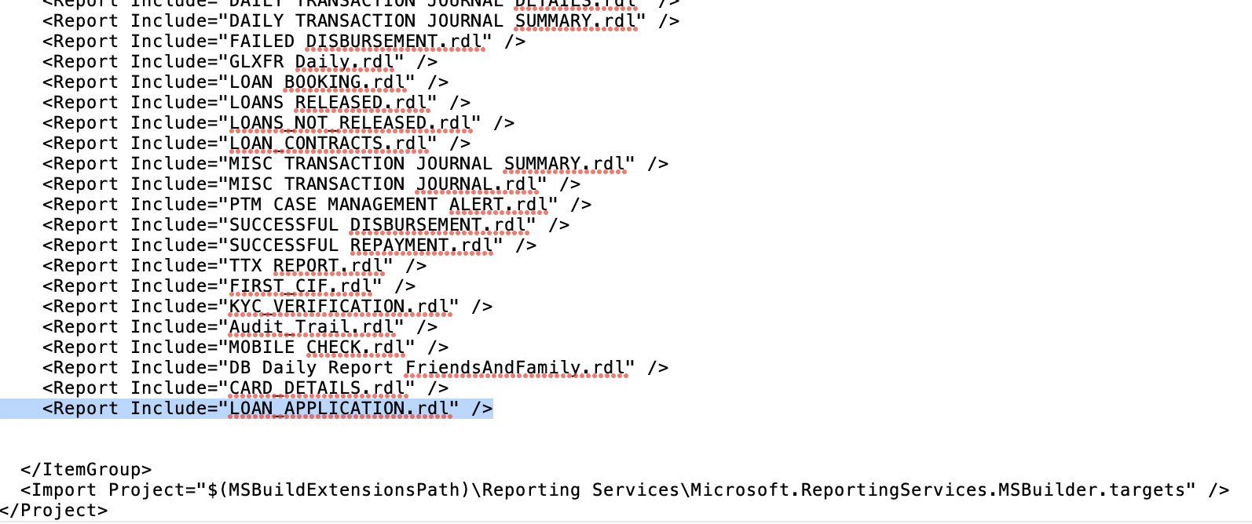

* Ready to git add, commit and push in the repos. Please see notes on Git
* Create pull request and Request for approval to Database rs (DBA) and to Gil

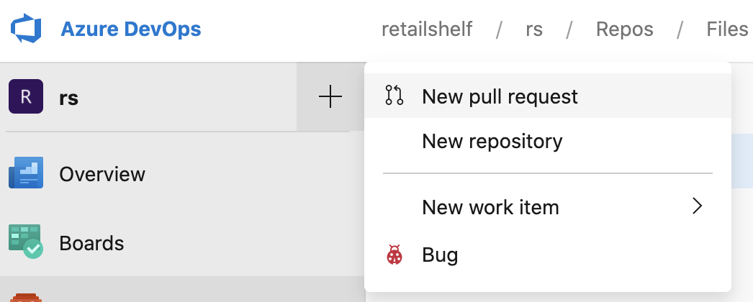

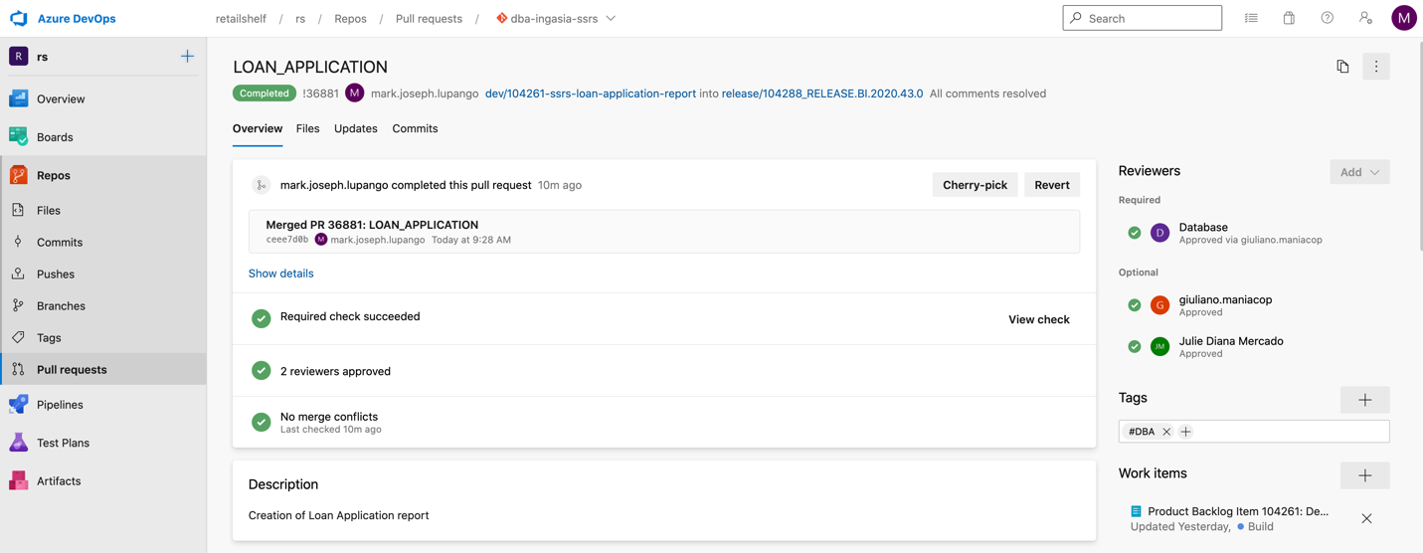

* Select complete and complete merge

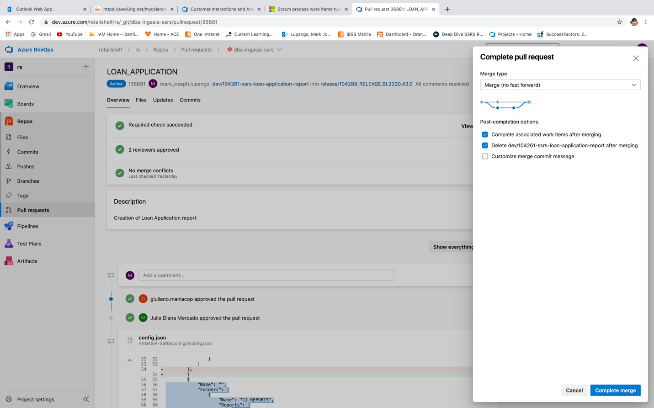

* Request for pre-UAT approval

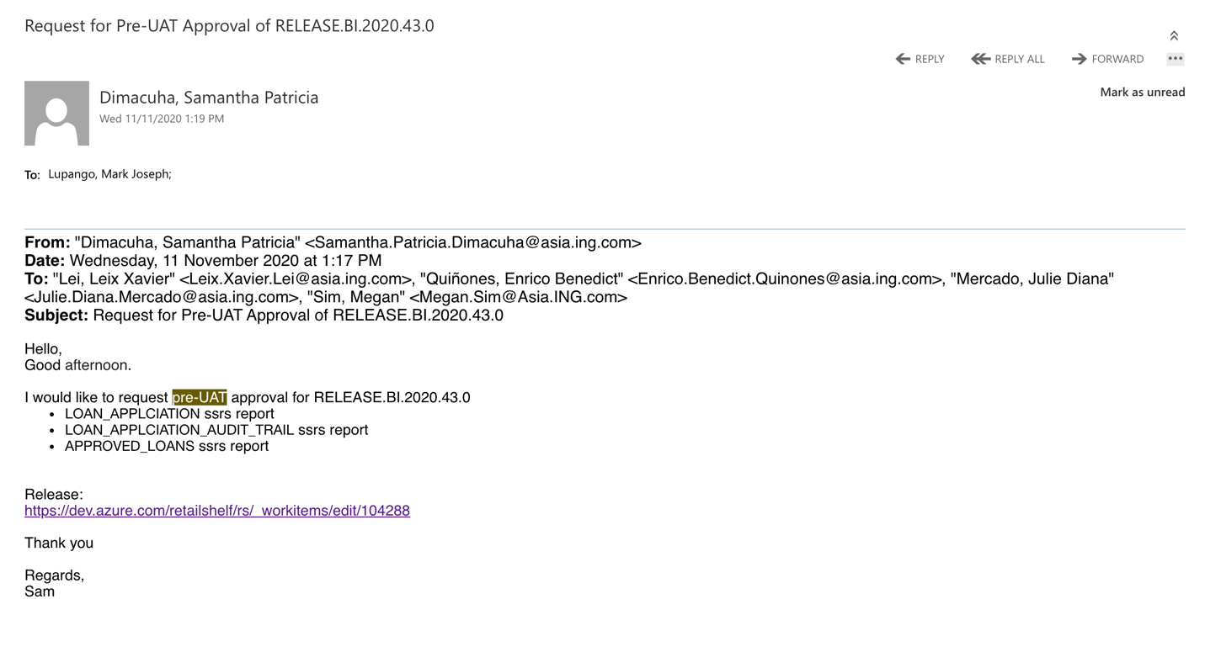

* <https://dev.azure.com/retailshelf/rs/_release?_a=releases&view=mine&definitionId=170> deployment to prod link (naligaw)

<https://dev.azure.com/retailshelf/rs/_releaseProgress?_a=release-pipeline-progress&releaseId=10110> - status for deployment

* For UAT deployment
* ID deployed (change status to “ready for test”)

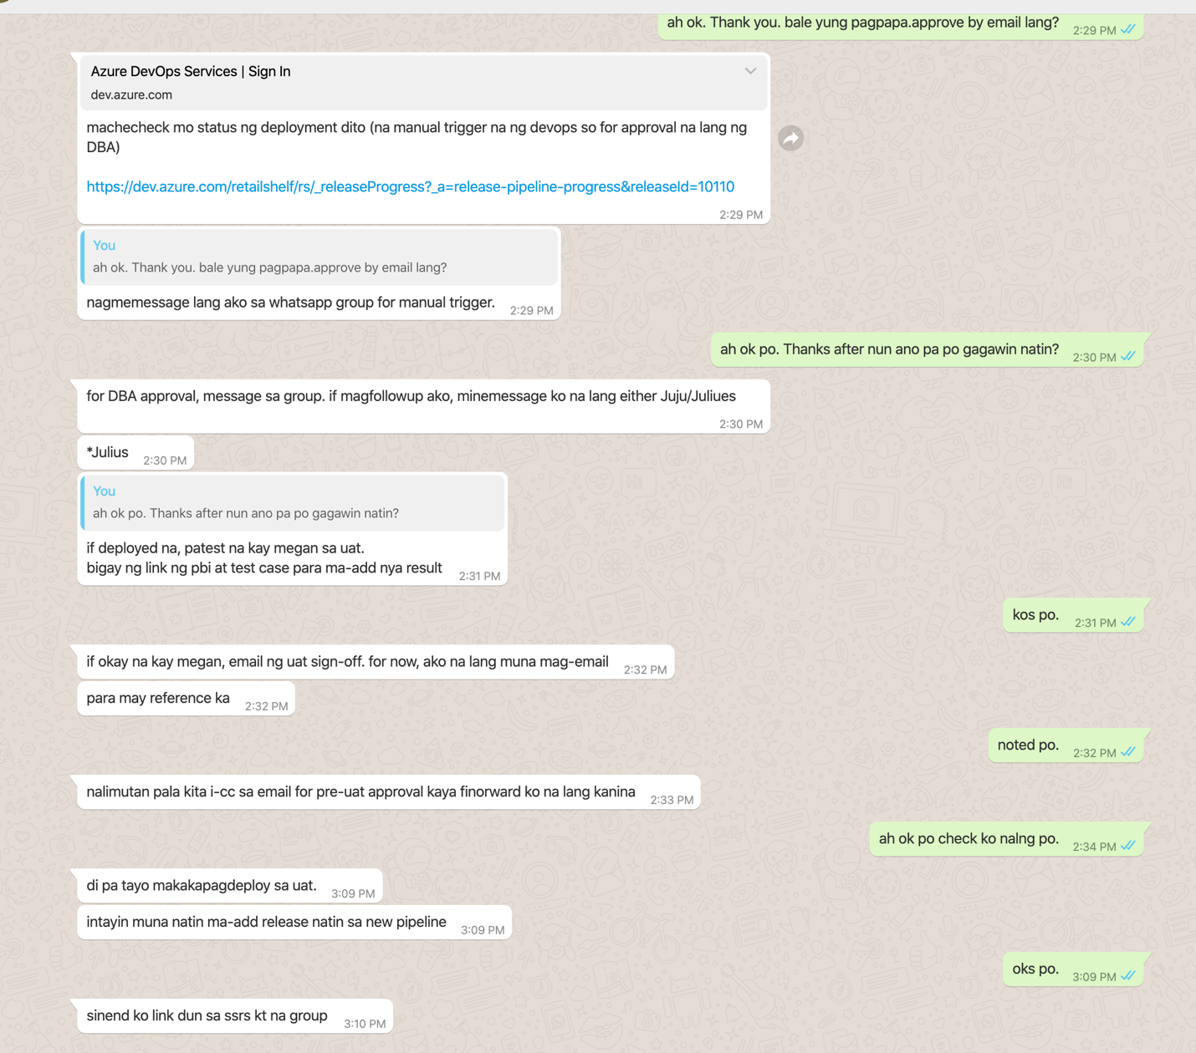

-test na di ko na nasundan because it to broad and many

<https://dev.azure.com/retailshelf/rs/_releaseProgress?releaseId=10141&_a=release-pipeline-progress> - for checking ng status , dapat updated na din yung link sa PBI

* For sign off

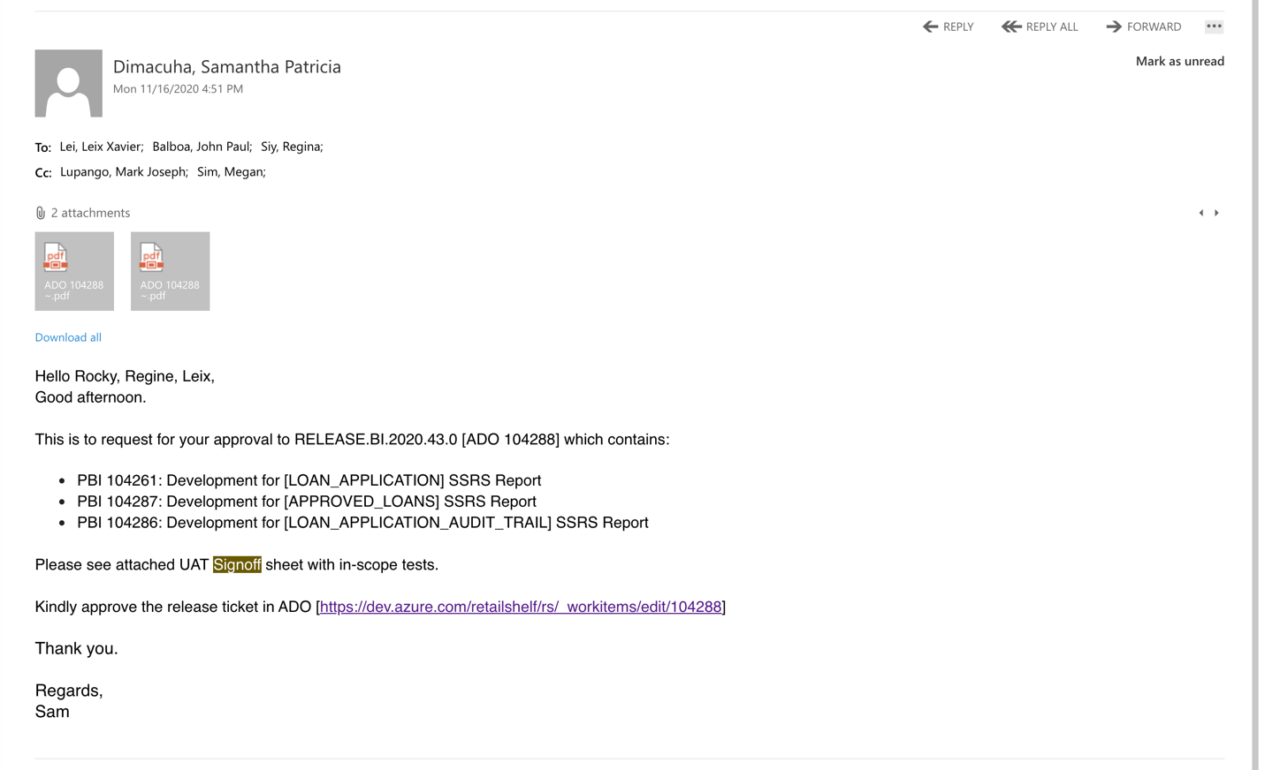

* Prod deployment

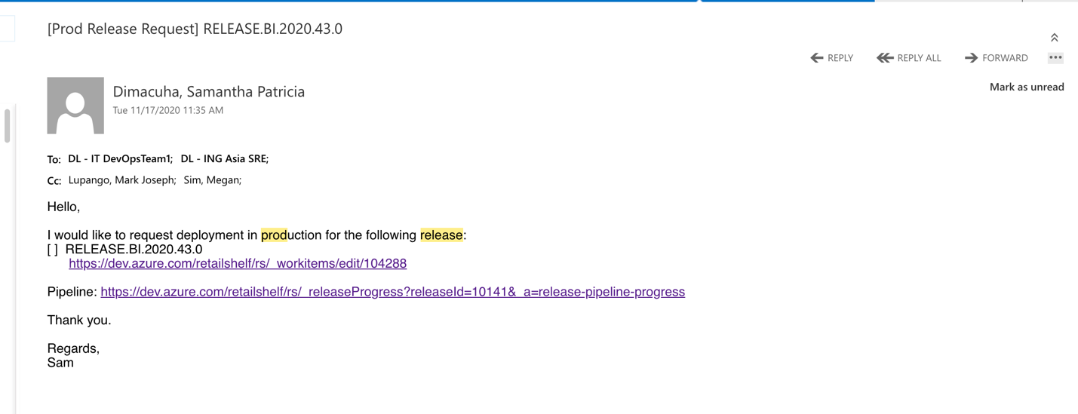

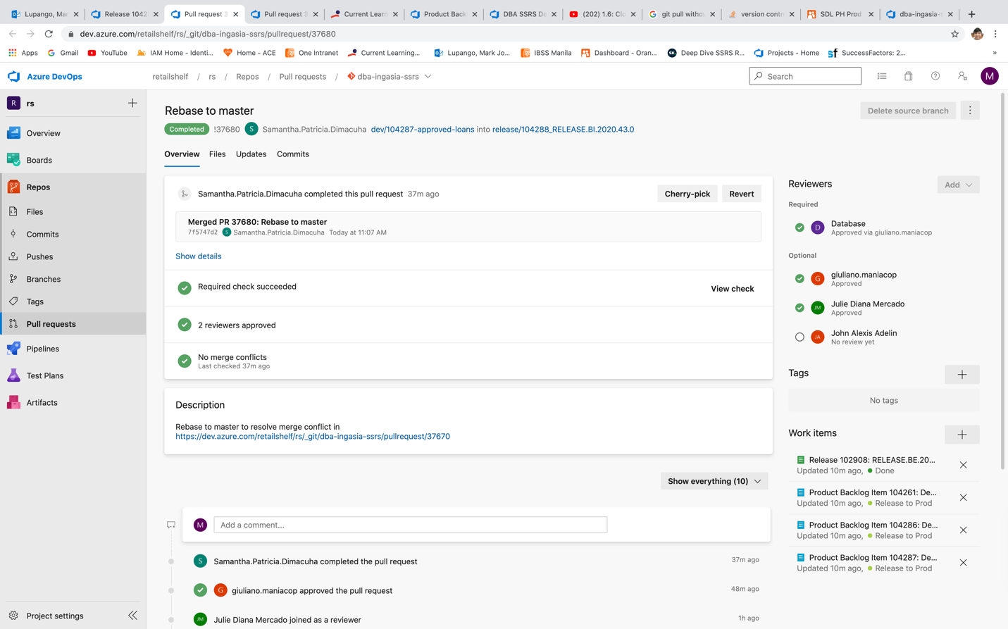

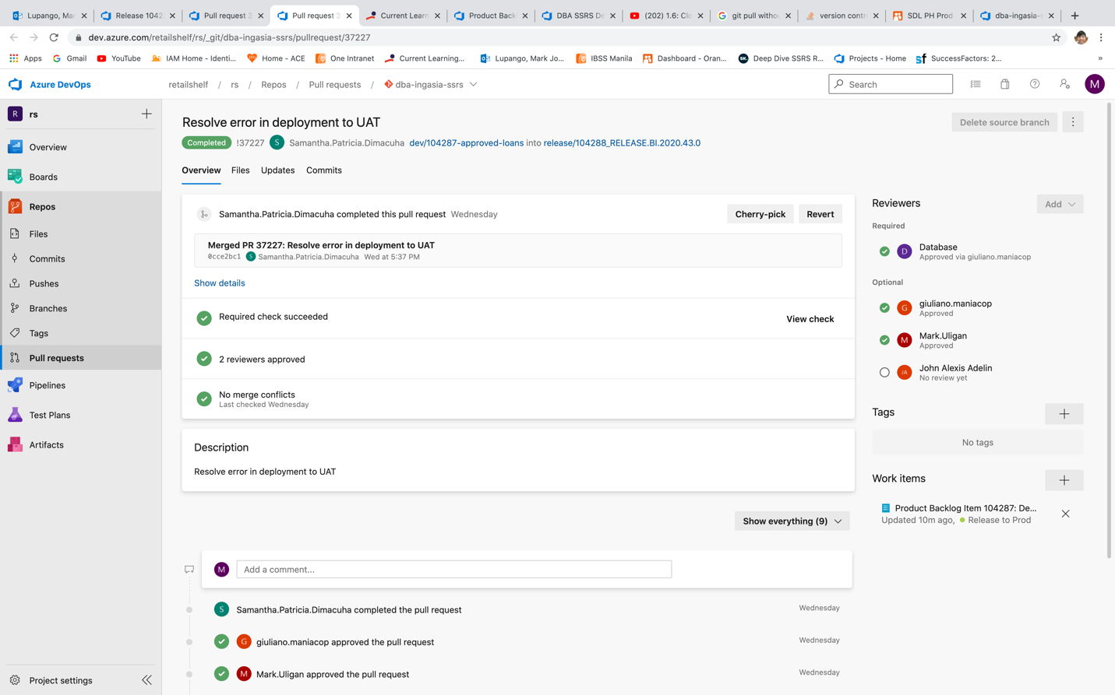

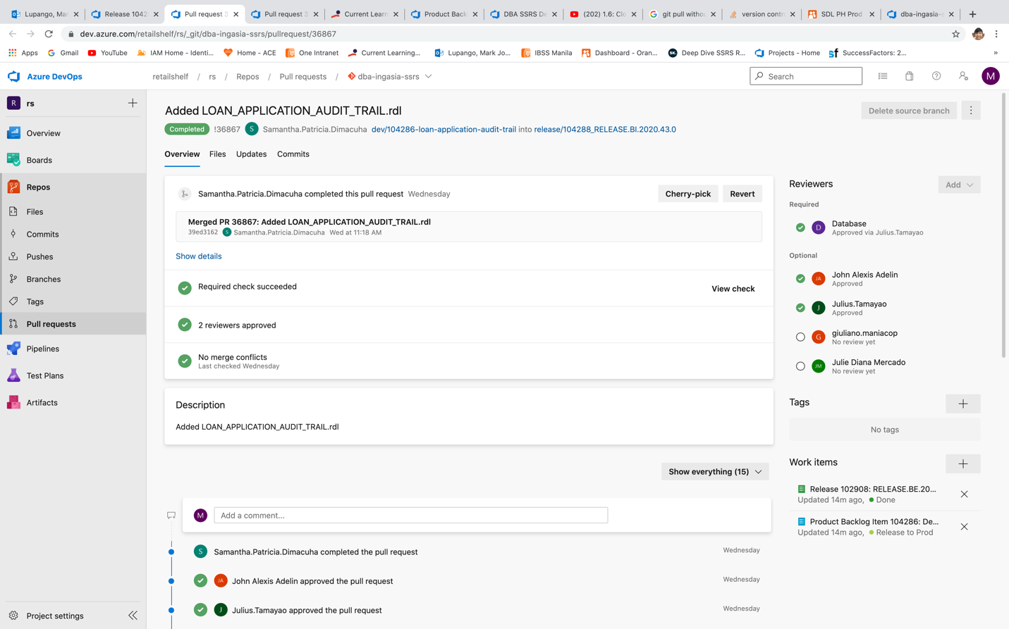

* Soll Matrix Report

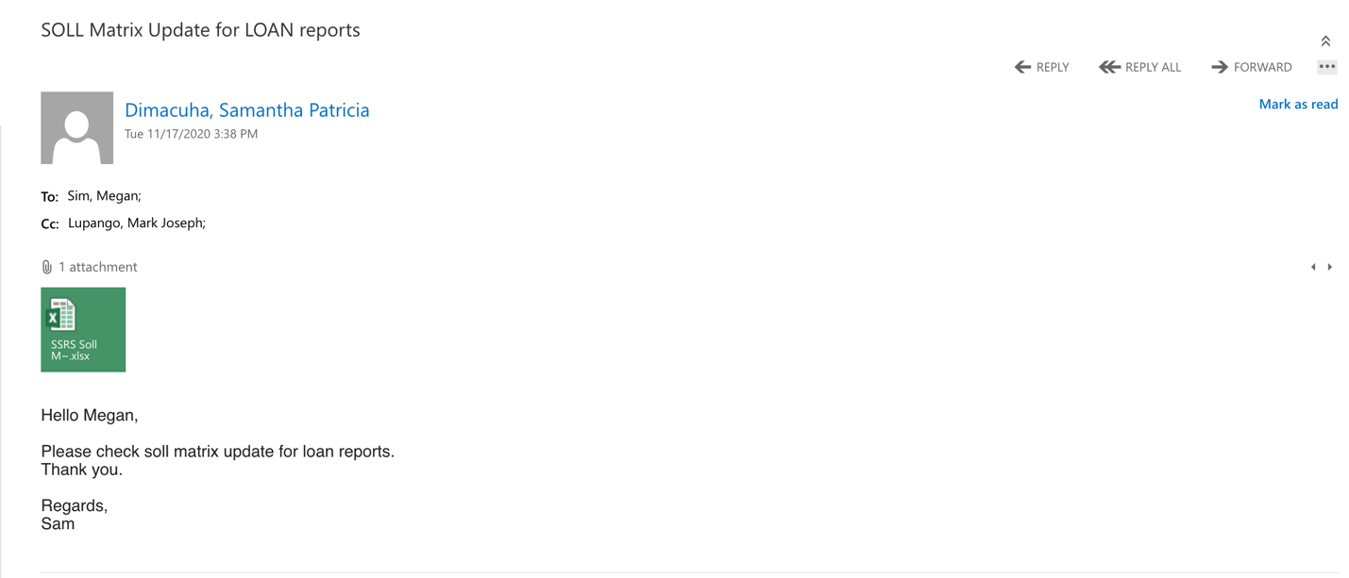

* Request for SOLL Matrix Update

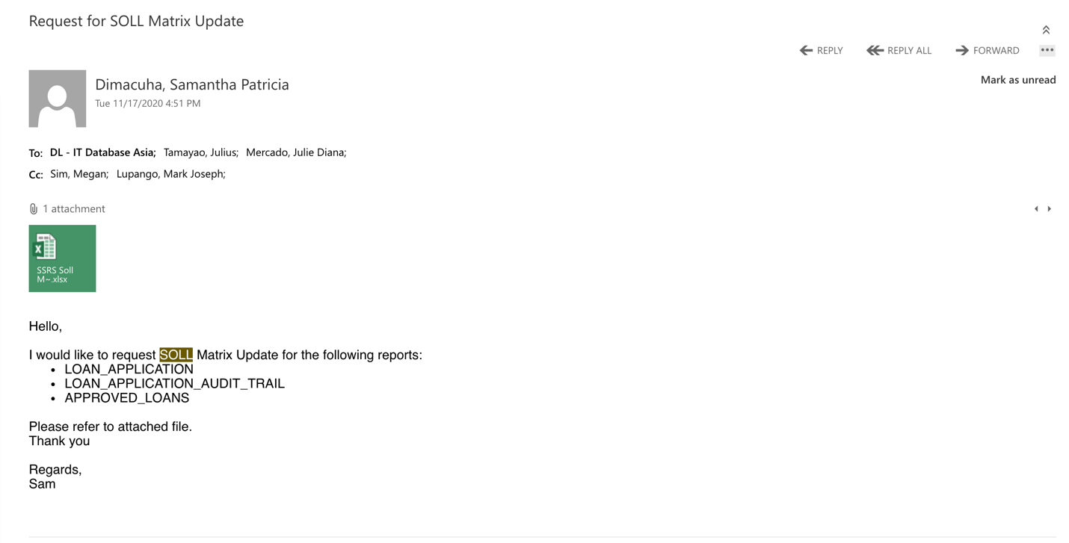

**DBA Thing**

<https://orangesharing.com/display/ENG/Database+Engineering> - all about Database Engineering

<https://orangesharing.com/display/ENG/Database+Pipeline+Solution> - Database pipeline solution

<https://www.youtube.com/watch?v=X48VuDVv0do&t=3244s> - kubernetes

<https://www.youtube.com/watch?v=NKEFWyqJ5XA> - Azure certification

<https://www.youtube.com/watch?v=VokDM-XLpUI> - practice test

<https://www.youtube.com/watch?v=kikcPTxcYCA> -1

<https://www.youtube.com/watch?v=vVSVX-86Qxs> -2

<https://www.youtube.com/watch?v=7DK0pwnzKLk> -3

<https://www.liquibase.com/ci-cd> - liquibase

DataTools2021! - synapse

Highlight the table and Alt F1 - to see details of table

Use this for safety:

Begin tran (Rollback or Commit)

<https://www.youtube.com/watch?v=29AqZm2yVYo> - for database comparison

[ingASIA-ssrs.southeastasia.cloudapp.azure.com](http://ingASIA-ssrs.southeastasia.cloudapp.azure.com) - winstag [WW80XC:Ing-4316]

Standard in Database

<https://orangesharing.com/pages/viewpage.action?spaceKey=ENG&title=Database+Development+Standards+and+Best+Practices>

dbcc checkdb(onepam)

select session_id, percent_complete , last_wait_type , wait_resource, wait_time, wait_type from sys.dm_exec_requests where status = ’rollback’

Dbcc onepam

Avalongame.online

Managing SQL performance:

* to see version

SELECT @@VERSION AS [Server_Version];

SELECT SERVERPROPERTY('ProductBuild') as BuildNumber,

SERVERPROPERTY('ProductLevel') as VersionLevel,

SERVERPROPERTY('ProductMajorVersion') as MajorVersion,

SERVERPROPERTY('ProductMinorVersion') as MinorVersion,

SERVERPROPERTY('ProductUpdateLevel') as UpdateLevel,

SERVERPROPERTY('ProductUpdateReference') as UpdateReference,

SERVERPROPERTY('ProductVersion') as ProductVersion;

* To see edition

SELECT @@VERSION AS [Server_Version_Edition];

SELECT SERVERPROPERTY('Edition') as Edition;

* To see error log

EXEC sp_readerrorlog 0, 1, 'Copyright';

**SDL**

CI - Customer Interaction or Data Management (IT Area)

CIA - Customer Interaction Account (For tribe name)

EDL - Enterprise Data Lake

SDL - Share Data Lake

DLTM - Data Lake Transfer Model

GRDM - Global Reference Data Model

IWH - Information Warehouse

CLP - Consumer Lending Post-Dayend

data management under CIA tribe.

<https://xenapp-dt.ad.ing.net/Citrix/XenApp-DTWeb/> - Citrix

<https://www.citrix.com/downloads/workspace-app/mac/workspace-app-for-mac-latest.html> - Citrix to be downloaded

<https://aveksa.iam.ing.net/> - Aveska

<https://www.youtube.com/watch?v=UWVc_DNj0xw> - Automate SSIS Package

<https://www.youtube.com/watch?v=2Ox4A1JASrI&feature=emb_rel_pause> - SSIS Project deployment

<https://www.youtube.com/watch?v=svstYRLthJY> - creating jobs

<https://www.youtube.com/watch?v=8OmDNMp4fWo> - call sql job from procedure

<https://www.youtube.com/watch?v=tw76kGrb6Ks&list=PLmhoQ1nd8VnQ8ScR5TxGdW7hUBsUpFT3n> - SSIS Full Tutorial

<https://www.youtube.com/watch?v=YYkqkCNBhnE> - troubleshoot SSIS errors

<https://www.youtube.com/watch?v=iAP8XeGBseg> - ETL data stage (part 1 - 3)

<https://www.youtube.com/watch?v=EllLYjkLR2A> - job sequencer

<https://www.youtube.com/watch?v=HZsIF7eoihs> - transformer stage (Part 1 and 2)

<https://www.youtube.com/watch?v=iF01Cai4zkc> - parallel jobs (Extract)

<https://www.youtube.com/watch?v=8c1BL5b47kg> - unix command

<https://www.geeksforgeeks.org/cp-command-linux-examples/#:~:text=cp> %20command%20require%20at%20least,to%20Destination%20file%20or%20Directory - unix article

<https://www.youtube.com/watch?v=oT_bjYUO4RQ> - Oracle SQL Developer

<https://www.ibm.com/support/knowledgecenter/SSZJPZ_11.7.0/com.ibm.swg.im.iis.ds.fd.doc/topics/c_dsfd_overview.html> - ibm knowledge center

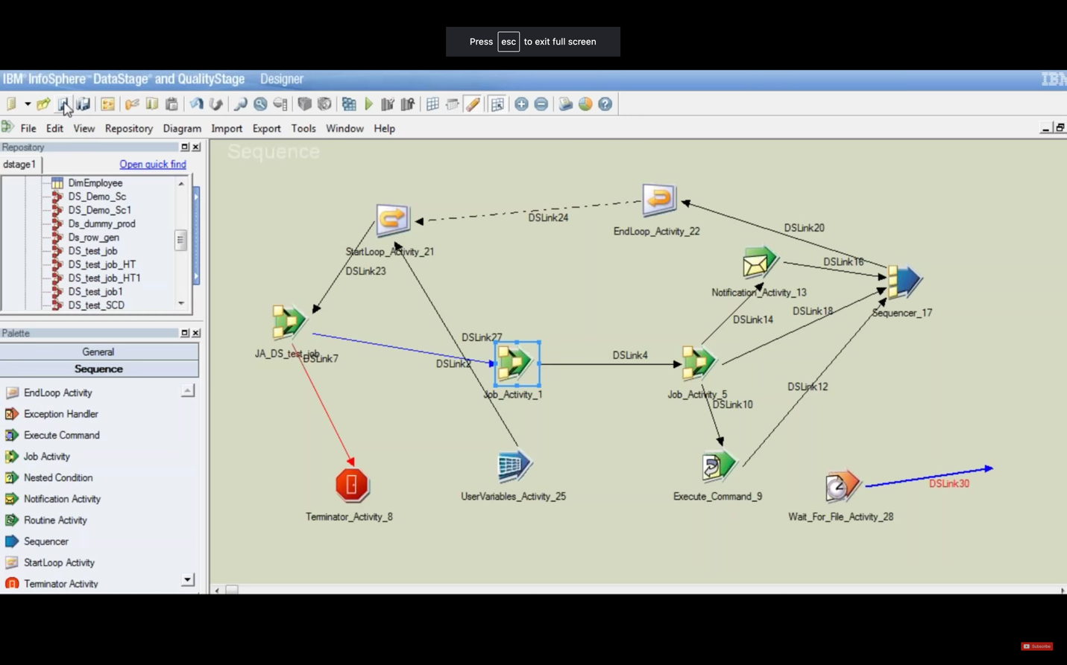

TEST

SX9000042122.ad.ing.net

clrv0000181828.ic.ing.net:9445/PH_DATA_LAKE

clrv0000181828.ic.ing.net:9445/FEATURE_PH

https://clrv0000181828.ic.ing.net:9445/ibm/iis/launchpad/

https://clrv0000181828.ic.ing.net:9445/ibm/iis/igc/

XMETA Repository - XCO & FEATURES Schemas - PH

Hostname: xbi403-scan.dbaas.ing.net

Port: 1521

Service name: SDL1171TGS1_1923.ac.dbaas

XCO_PH / XCO_PH_READ / XCO_PH_WRITE                                                        => EYtRgdmmzMuW1

FEATURES_PH / FEATURES_PH_READ / FEATURES_PH_WRITE                    => EYtRgdmmzMuW1

# (IIS) Engine Tier – PH Zone: clrv0000181827.ic.ing.net

dsusr_ph@ 1amHungry

# (LZ) Landing Zone – PH Zone (sFTP) : clrv0000126377.ic.ing.net

lzsftp_ph@ 1amHungry

# (LZ) Landing Zone – PH Zone (XFB) : clrv0000126377.ic.ing.net

xfbcft_ph@ 1amHungry

<https://orangesharing.com/display/ENG/SDL+PH+Prod+Support+Guide>

<https://orangesharing.com/display/ENG/SDL+PH+Prod+Support+Guide>

<https://www.citrix.com/downloads/workspace-app/mac/workspace-app-for-mac-latest.html> - Citrix download

<https://cs-asia.ing.net/sites/DataManagementCandGAsia/_layouts/15/start.aspx#/Shared%20Documents/Forms/AllItems.aspx?RootFolder=%2fsites%2fDataManagementCandGAsia%2fShared%20Documents%2f02%2dData%20Products&FolderCTID=0x0120007E25E68A75DAEA41B97C74021E1D114B>

<https://cs-asia.ing.net/sites/DataManagementCandGAsia/Shared%20Documents/02-Data%20Products/02-PH%20Project%20Anilao/02-Design/OST%20Anilao%20Mapping.xlsx?Web=1>

cp /data/Projects/PH_DATA_LAKE/files/inputfiles/DM/PH_GlobalPowerBI_OPAM_src_files_lynx/hist_rtb.approval_workflow_request_20201014_20201110170926_2e84d00a368a2a5bad34ac0b5245107b.csv /data/Projects/PH_DATA_LAKE/files/inputfiles/ - for unix copy

/data/Projects/PH_DATA_LAKE/files/inputfiles/DM/PH_GlobalPowerBI_OPAM_src_files_lynx - unix

/data/Projects/PH_DATA_LAKE/files/inputfiles/ - inputfiles unix

P)VlrDBR6VA2O>$J - pw

<https://cs-asia.ing.net/sites/DataManagementCandGAsia/Shared%20Documents/02-Data%20Products/02-PH%20Project%20Anilao/02-Design/OST%20Anilao%20Mapping.xlsx?Web=1>

<https://dev.azure.com/retailshelf/rs/_workitems/edit/95759> - phi

INSERT INTO iam.FUNCTION_DEFINITION (ASSETS_FUNCTION_CODE , ASSETS_FUNCTION_CODE_DESCRIPTION , PERMISSION_CODE , CREATED_BY , CREATED_DATETIME , EFFECTIVE_START_DATE , METHOD, PATH , SERVICE_NAME) VALUES ( 'NTF_D' , 'Notifications - Details' , 'R' , SUSER_SNAME() , GETUTCDATE() , GETUTCDATE() , 'GET','/mass-notification/notificationmessage/details','massnotification');

OST Anilao Mapping Document:

<https://cs-asia.ing.net/sites/DataManagementCandGAsia/Shared%20Documents/02-Data%20Products/02-PH%20Project%20Anilao/02-Design/OST%20Anilao%20Mapping.xlsx?Web=1>

UNIT Test Sample Doc

<https://cs-asia.ing.net/sites/DataManagementCandGAsia/Shared%20Documents/Forms/AllItems.aspx?RootFolder=%2Fsites%2FDataManagementCandGAsia%2FShared%20Documents%2F02%2DData%20Products%2F02%2DPH%20Project%20Anilao%2F11%2DDevelopment%2FVORTEX%5FIteration%5F1&FolderCTID=0x0120007E25E68A75DAEA41B97C74021E1D114B&View=%7B409F06CF%2DE73E%2D4042%2DAF57%2D2B27ED8D6302%7D&InitialTabId=Ribbon%2EDocument&VisibilityContext=WSSTabPersistence#InplviewHash409f06cf-e73e-4042-af57-2b27ed8d6302=Paged%3DTRUE-p_SortBehavior%3D0-p_FileLeafRef%3DUT%2520IWH%2520%252dPH%255fIW%255fSQ%255fPD%255fNON%255fFM%255fPD%255fV%255f%255fLN%255fPD%255fCL%255fPRP2IWH%252edoc-p_ID%3D2553-RootFolder%3D%252fsites%252fDataManagementCandGAsia%252fShared%2520Documents%252f02%252dData%2520Products%252f02%252dPH%2520Project%2520Anilao%252f11%252dDevelopment%252fVORTEX%255fIteration%255f1-PageFirstRow%3D31>

Unit Testing Doc Template OST:

<https://cs-asia.ing.net/sites/DataManagementCandGAsia/Shared%20Documents/02-Data%20Products/01-PH%20Shared%20Data%20Lake/Templates/UT%20OST%20Template.doc?Web=1>

TEST Credentials:

[dsusr_ph@**clrv0000181827.ic.ing.net**](mailto:dsusr_ph@clrv0000181827.ic.ing.net) **:** P)VlrDBR6VA2O>$J - for MobaXterm

[lzsftp_ph@**clrv0000126377.ic.ing.net**](mailto:lzsftp_ph@clrv0000126377.ic.ing.net)**:** 1amHungry

Oracle:                                                                                                                   Host                                                       port        service name

|  |  |  |  |  |  |
| --- | --- | --- | --- | --- | --- |
| TEST DDL | PH_OS_OST_ADMIN | osostadminPH01 | xbi301-scan.dbaas.ing.net | 1521 | SDLTESTPH_1923 |
|  | PH_OS_STG_ADMIN | osstgadminPH01 |  |  |  |
|  | PDBADMIN | tOSOw4iPWC |  |  |  |
|  | PH_CI_ADMIN | phciadminPH01 |  |  |  |
|  | PH_OS_OST_READ | osostadminPH01 |  |  |  |

Regards,

Angelo Jerome de Leon

IT-Engineering

WP20 A77



ING Business Shared Services B.V. Branch Office

World Plaza, Fifth Avenue, E-Square Zone

Crescent Park West, Bonifacio Global City, Taguig

Philippines, 1634

<https://dev.azure.com/retailshelf/rs/_workitems/edit/99978> - RELEASE TICKET SAMPLE

<https://dev.azure.com/retailshelf/rs/_workitems/edit/100491> - ISA PA

99284 - ADD LINK

cd /data/Projects/PH_DATA_LAKE/files/inputfiles/

To see data:

cat hist_sdm.message_topic_20201014_20201110170925_0b0b0079536e6f72c001b9e5ea8fd4ee.csv | tr -d '\n' | tr '\r' '\n' > hist_sdm.message_topic_20201014_20201110170925_0b0b0079536e6f72c001b9e5ea8fd4ee_tmp.csv

q: sa ost lang ba to?

CREATE SEQUENCE "PH_OS_OST_ADMIN"."D2_MESSAGE_TOPIC_S_SEQ" MINVALUE 1 MAXVALUE 9999999999999999999999999999 INCREMENT BY 1 START WITH 1 CACHE 20 NOORDER NOCYCLE NOKEEP NOSCALE GLOBAL ;

CREATE OR REPLACE EDITIONABLE TRIGGER "PH_OS_OST_ADMIN"."D2_MESSAGE_TOPIC_S_TRG"

BEFORE INSERT ON PH_OS_OST_ADMIN.D2_MESSAGE_TOPIC_S

FOR EACH ROW

BEGIN

IF :new.D2_MESSAGE_TOPIC_S_ID IS NULL THEN

:new.D2_MESSAGE_TOPIC_S_ID := D2_MESSAGE_TOPIC_S_SEQ.NEXTVAL;

END IF;

END;

/

ALTER TRIGGER "PH_OS_OST_ADMIN"."D2_MESSAGE_TOPIC_S_TRG" ENABLE;

--OST GRANT statement

GRANT SELECT ON PH_OS_OST_ADMIN.D2_MESSAGE_TOPIC_S TO PH_OS_OST_READ;

GRANT SELECT, INSERT, UPDATE, DELETE ON PH_OS_OST_ADMIN.D2_MESSAGE_TOPIC_S to PH_OS_OST_APP;

GRANT SELECT ON PH_OS_OST_ADMIN.D2_MESSAGE_TOPIC_S to PH_OS_OST_READ WITH GRANT OPTION;

—STG GRANT statements

GRANT SELECT, INSERT, UPDATE, DELETE ON PH_OS_STG_ADMIN.STG_MESSAGE_S TO PH_OS_STG_APP;

———— Changed filename etc.

cat hist_rtb.feedback_20201014_20201110170934_cde6aa0082b20ed3ee97f69e3a969b72.csv | tr -d '\n' | tr '\r' '\n' > hist_rtb.feedback_20201014_20201110170934_cde6aa0082b20ed3ee97f69e3a969b72_tmp.csv

-for Creating Sequence

CREATE SEQUENCE "PH_OS_OST_ADMIN"."D2_FEEDBACK_S_SEQ" MINVALUE 1 MAXVALUE 9999999999999999999999999999 INCREMENT BY 1 START WITH 1 CACHE 20 NOORDER NOCYCLE NOKEEP NOSCALE GLOBAL ;

-for Creating Trigger

CREATE OR REPLACE EDITIONABLE TRIGGER "PH_OS_OST_ADMIN"."D2_FEEDBACK_S_TRG"

BEFORE INSERT ON PH_OS_OST_ADMIN.D2_FEEDBACK_S

FOR EACH ROW

BEGIN

IF :new.D2_FEEDBACK_S_ID IS NULL THEN

:new.D2_FEEDBACK_S_ID := D2_FEEDBACK_S_SEQ.NEXTVAL;

END IF;

END;

* To alter trigger

ALTER TRIGGER "PH_OS_OST_ADMIN"."D2_FEEDBACK_S_TRG" ENABLE;

* To GRANT OST - (DI ko narun nag.eeror yang grant option)

GRANT SELECT ON PH_OS_OST_ADMIN.D2_FEEDBACK_S TO PH_OS_OST_READ;

GRANT SELECT, INSERT, UPDATE, DELETE ON PH_OS_OST_ADMIN.D2_FEEDBACK_S to PH_OS_OST_APP;

GRANT SELECT ON PH_OS_OST_ADMIN.D2_FEEDBACK_S to PH_OS_OST_READ WITH GRANT OPTION;

* To GRANT STG

GRANT SELECT, INSERT, UPDATE, DELETE ON PH_OS_STG_ADMIN.STG_FEEDBACK TO PH_OS_STG_APP;

New

dsusr_ph@ .z$wNV4-M7;W>)[z

lzsftp_ph@ k2N4ALxa

xfbcft_ph@ k2N4ALxa

PH_GCH_ADMIN - v8z7L7GZFj

StringToTimestamp(rea_D2_FEEDBACK.CREATED_DATETIME, "%(m,s)/%(d,s)/%yyyy %(H,s):%(n,s):%(s,s) %(aa,u)")

StringToTimestamp(rea_D2_FEEDBACK.UPDATED_DATETIME, "%(m,s)/%(d,s)/%yyyy %(H,s):%(n,s):%(s,s) %(aa,u)")

Meeting with Gelo, sol matrix, testing and others

nrtvX2fn

# (LZ) Landing Zone – PH Zone (sFTP) : clrv0000152294.ic.ing.net

lzsftp_ph@ LtI26P7x

# (LZ) Landing Zone – PH Zone (XFB) : clrv0000152294.ic.ing.net

xfbcft_ph@ nrtvX2fn

<https://dev.azure.com/retailshelf/rs/_workitems/edit/108669>

[audric.dane.austria@asia.ing.com](mailto:audric.dane.austria@asia.ing.com)

[nonprod-4-resource-vm0.southeastasia.cloudapp.azure.com](http://nonprod-4-resource-vm0.southeastasia.cloudapp.azure.com)

RPT512CNW

123@BCde

[ingasia-ssrs.southeastasia.cloudapp.azure.com](http://ingasia-ssrs.southeastasia.cloudapp.azure.com)

UA: ssdt_admin

pw: P@77w0rd2018

C:\Users\ssdt_admin\source\repos\Integration Services Project2\Integration Services Project2.sln

<http://ingasia-ssrs.southeastasia.cloudapp.azure.com/reports/browse/CI%20REPORTS/Datalake>

DEVTEST LOANS, ONEPAM

172.200.2.4

DEVTEST CARDS

 172.23.1.21

super123@BCde

username: sa

select

TABLE_CATALOG,

TABLE_SCHEMA,

TABLE_NAME,

COLUMN_NAME,

DATA_TYPE,

ORDINAL_POSITION,

SYSDATETIME(),

'WIN2016DBSTAG\dbadmin',

SYSDATETIME(),

'WIN2016DBSTAG\dbadmin'

FROM INFORMATION_SCHEMA.COLUMNS

where TABLE_CATALOG = 'LOANS'

AND TABLE_NAME IN ('LOANS_PURPOSE','LOAN_APPLICATION');

[nonprod-staging-resource-vm0.southeastasia.cloudapp.azure.com](http://nonprod-staging-resource-vm0.southeastasia.cloudapp.azure.com)

Shared Data Lake Dossier - <https://orangesharing.com/pages/viewpage.action?spaceKey=CGA&title=Shared+Data+Lake+Dossier>

Soll Matrix Templates - <https://confluence.europe.intranet/pages/viewpage.action?spaceKey=SOLL&title=00+SOLL+template+forms+and+examples>

Roles - <https://confluence.europe.intranet/display/SDL/61.+IAM+for+SDL>

<https://clrv0000181828.ic.ing.net:9445/ibm/iis/igc/#dossierEdit/6662c0f2.fbf2418e.2ek7chktl.ebelj8a.21835n.e3bluqtbvhfdv0npe453l>

**MobaXerm**

Login

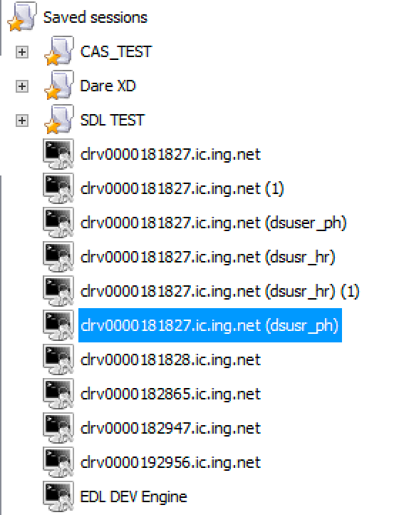

Pw: P)VlrDBR6VA2O>$J

New PW:

Path - pwd

cd /data/Projects/PH_DATA_LAKE/files/inputfiles/DM/PH_GlobalPowerBI_OPAM_src_files_lynx

Change path - cd /data/Projects/PH_DATA_LAKE/files/inputfiles/

ls -lrt ( to see the list)

cd DM - to go to DM folder

ls -lrt ( to see the list in DM folder)

cd PH_GlobalPowerBI_OPAM_src_files_lynx

ls -lrt (to see that is in the above path)

cp <filename1> <filename2>

**cp Src_file1 Src_file2 Src_file3 Dest_directory - be carful it might override if the filename is already existing**

cp hist_rtb.feedback_20201014_20201110170934_cde6aa0082b20ed3ee97f69e3a969b72.csv /data/Projects/PH_DATA_LAKE/files/inputfiles/

cp dum_delta_rtb.feedback_20201015_20201110172039_1fe4ad4609503fc7352f52cc013582e2.csv /data/Projects/PH_DATA_LAKE/files/inputfiles/DM/PH_GlobalPowerBI_OPAM_src_files_lynx

- dyan mo kokopyahin

head -1 <file.txt> (to see header, change depending on the number of row you want to see)

**tr -** translate

> - copy

Script for cleaning data :

cat hist_rtb.feedback_20201014_20201110170934_cde6aa0082b20ed3ee97f69e3a969b72.csv | tr -d '\n' | tr '\r' '\n' > hist_rtb.feedback_20201014_20201110170934_cde6aa0082b20ed3ee97f69e3a969b72_tmp.csv

Head -10 <file_name>

Rm -remove files rm <name of the files>

Awk - to manipulate data rows or column

mv <file.csv> <newfile.csv> - to move or rename (override)

md5sum <file.csv>

New PW: >q9C5}BCj.8rPTwN. > dsusr_ph@ d%V*A)81>{>P@z5$

dsusr_ph@ .z$wNV4-M7;W>)[z

lzsftp_ph@ k2N4ALxa

xfbcft_ph@ k2N4ALxa

PH_GCH_ADMIN - v8z7L7GZFj

clrv0000181827.ic.ing.net

**Kubernetes**

minikube - for start up/delleting the cluster

kubectl - for configuring the Minikube cluster

minikube start —vm-driver=hyperkit

minikube status - to know the status

kubectl get nodes

kubectl version

**install hyperhit and minikube**

brew update

brew install hyperkit

brew install minikube

kubectl

minikube

**create minikube cluster**

minikube start --vm-driver=hyperkit

kubectl get nodes

minikube status

kubectl version

**delete cluster and restart in debug mode**

minikube delete

minikube start --vm-driver=hyperkit --v=7 --alsologtostderr

minikube status

**kubectl commands**

kubectl get nodes

kubectl get pod

kubectl get services

kubectl create deployment nginx-depl --image=nginx

kubectl get deployment

kubectl get replicaset

kubectl edit deployment nginx-depl

**debugging**

kubectl logs {pod-name}

kubectl exec -it {pod-name} -- bin/bash

**create mongo deployment**

kubectl create deployment mongo-depl --image=mongo

kubectl logs mongo-depl-{pod-name}

kubectl describe pod mongo-depl-{pod-name}

**delete deplyoment**

kubectl delete deployment mongo-depl

kubectl delete deployment nginx-depl

**create or edit config file**

vim nginx-deployment.yaml

kubectl apply -f nginx-deployment.yaml

kubectl get pod

kubectl get deployment

**delete with config**

kubectl delete -f nginx-deployment.yaml

#Metrics

kubectl top The kubectl top command returns current CPU and memory usage for a cluster’s pods or nodes, or for a particular pod or node if specified.

VIM

**While in command mode (case sensitive)**

* move the cursor with arrow keys; if there aren't any arrow keys, use j,k,h,l
* i - change to insert mode (before cursor)
* a - change to insert mode (after cursor)
* A - change to insert mode (at end of line)
* r - replace one character
* R - overwrite text
* x - delete one character
* dd - delete one line
* yy - yank line (copy)
* p - paste deleted or yanked text after cursor
* P - paste deleted or yanked text before cursor
* G - go to end of the file
* 1G - go to top of the file
* J - merge next line with this one
* / - search, follow / with text to find
* :wq - write file and quit
* :q! - quit without saving
* %s/old/new/g - substitute; replace "old" with "new" on all lines
* :g/pattern/d - delete all lines that match the pattern

**While in insert mode**

* ESC - change to command mode
* any text typed is entered at the cursor

SELECT [appVersion]

,[usageIdentifier]

,[currentPage]

,[long]

,[bundleVersion]

,[type]

,[deviceBrand]

,[previousScreen]

,[deviceHeight]

,[deviceModel]

,[os]

,[osVersion]

,[channel]

,[isCompromised]

,[timeStamp]

,[deviceManufacturer]

,[sessionExpiry]

,[uniqueIdentifier]

,[deviceWidth]

,[connectionType]

,[sessionId]

,[language]

,[lat]

, CONVERT(binary,HASHBYTES('SHA2_512', CAST( cif as varchar))) [cif]

,[publicIp]

,[location]

,[timeStampDate]

,[sessionExpiryDate]

,[deviceModelName]

,[category]

,[payload]

,[label]

,[geo]

,[isReturning]

FROM [dbo].[elka]

**SSIS Extract Anilao**

<https://orangesharing.com/display/ENG/SSIS+to+SSRS+extract+ANILAO+files>

Meeting with Gelo, sol matrix, testing and others

nrtvX2fn

# (LZ) Landing Zone – PH Zone (sFTP) : clrv0000152294.ic.ing.net

lzsftp_ph@ LtI26P7x

# (LZ) Landing Zone – PH Zone (XFB) : clrv0000152294.ic.ing.net

xfbcft_ph@ nrtvX2fn

<https://dev.azure.com/retailshelf/rs/_workitems/edit/108669> - Sample of Whitlist tapas pa pipeline mo na (approve ni lex)

[audric.dane.austria@asia.ing.com](mailto:audric.dane.austria@asia.ing.com) - contact for approval ng whitelist (pwede din sa devops)

[nonprod-4-resource-vm0.southeastasia.cloudapp.azure.com](http://nonprod-4-resource-vm0.southeastasia.cloudapp.azure.com) - DB UAT4 (RPT)

RPT512CNW

123@BCde

[ingasia-ssrs.southeastasia.cloudapp.azure.com](http://ingasia-ssrs.southeastasia.cloudapp.azure.com) - ONEPAM (dito tayo kumukuha ng data)

UA: ssdt_admin

pw: P@77w0rd2018

C:\Users\ssdt_admin\source\repos\Integration Services Project2\Integration Services Project2.sln - this the path pero wala pa sa vm ko

<http://ingasia-ssrs.southeastasia.cloudapp.azure.com/reports/browse/CI%20REPORTS/Datalake> - (Ing-4316 same sa winstag)

Pag magiinsert band adware gagamitin:

DEVTEST LOANS, ONEPAM

172.200.2.4

DEVTEST CARDS

 172.23.1.21

super123@BCde

username: sa

Extraat data lake map query:

select

TABLE_CATALOG,

TABLE_SCHEMA,

TABLE_NAME,

COLUMN_NAME,

DATA_TYPE,

ORDINAL_POSITION,

SYSDATETIME(),

'WIN2016DBSTAG\dbadmin',

SYSDATETIME(),

'WIN2016DBSTAG\dbadmin'

FROM INFORMATION_SCHEMA.COLUMNS

where TABLE_CATALOG = 'LOANS'

AND TABLE_NAME IN ('LOANS_PURPOSE','LOAN_APPLICATION');

[nonprod-staging-resource-vm0.southeastasia.cloudapp.azure.com](http://nonprod-staging-resource-vm0.southeastasia.cloudapp.azure.com)

Shared Data Lake Dossier - <https://orangesharing.com/pages/viewpage.action?spaceKey=CGA&title=Shared+Data+Lake+Dossier>

Soll Matrix Templates - <https://confluence.europe.intranet/pages/viewpage.action?spaceKey=SOLL&title=00+SOLL+template+forms+and+examples>

Roles - <https://confluence.europe.intranet/display/SDL/61.+IAM+for+SDL>

RPT512CNW

123@BCde

Test Case Creation:

* Go to “Test Plans”
* Under “Mine” tab select CIA (to see all test plans under CIA)
* Now, go to Boards > Work Items : “+” then “New query”
* Run query and select TEST CASE OST

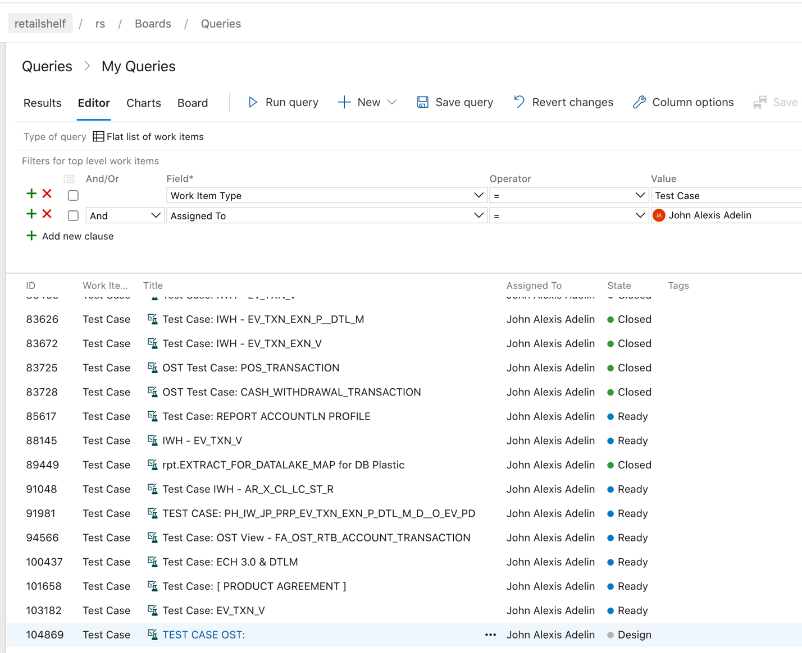

* Create a copy of a work item then click “Ok”

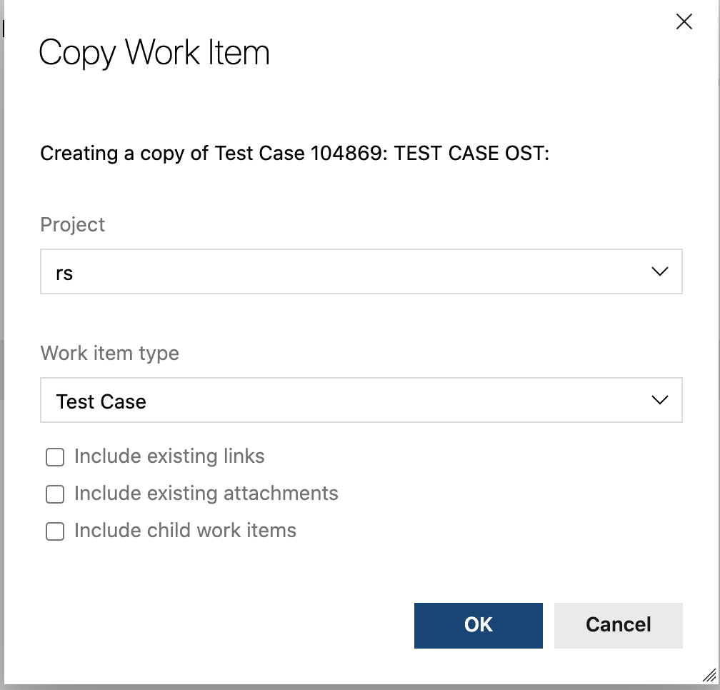

* Insert your Table Name then click “Save” to get the number



* Open you PBI then under “Related Work” > add link > Existing Item
* Add your test case number then add

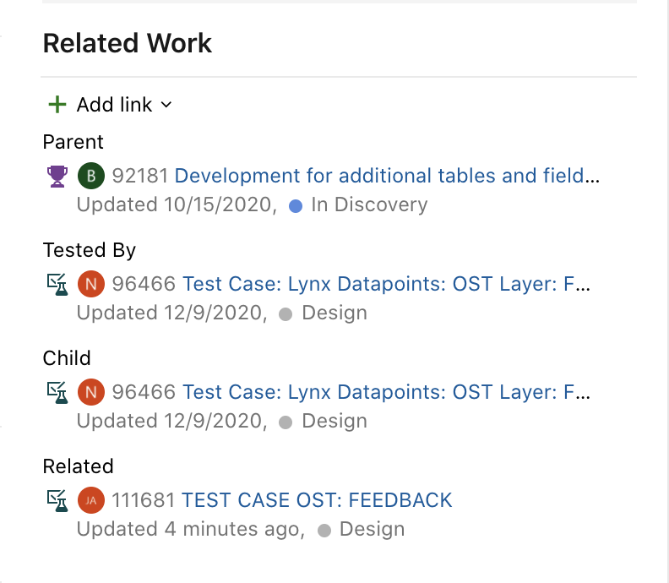

* Now contact Lex to register your PBI number and Test Case number
* Once registered, you can now test by running for web application (unblock the content that will pop-up)

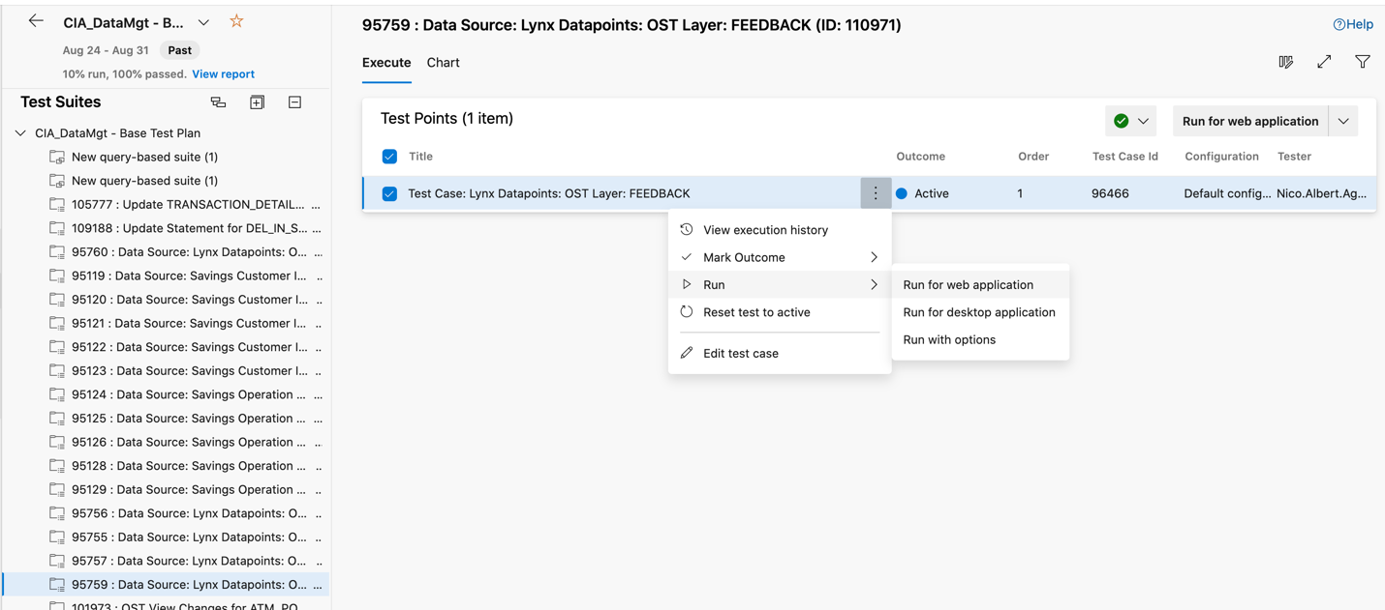

* Now, the tester can run the end to end run to test the Work you Do.
* The tester can pass or fail, put comment or attachment as an evidence.

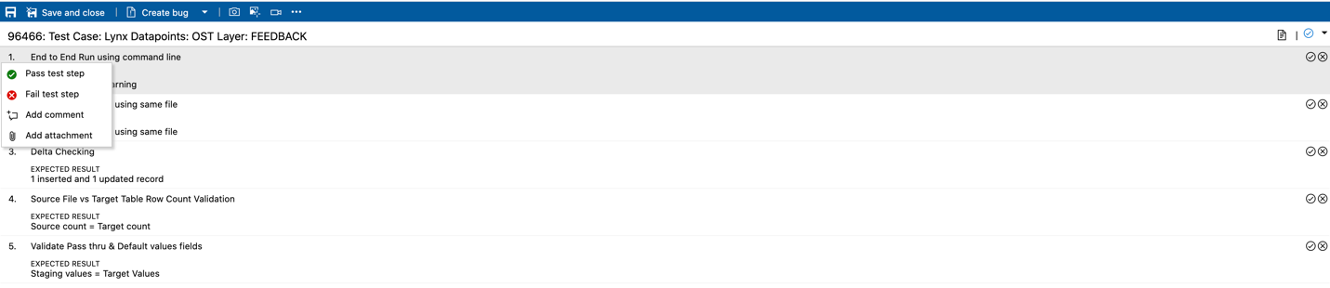

* After that, in your test run (wala kasi aka, lets imagine) > under “link”, link you PBI number and click “Add Work Item”
* Then Save and Close your PBI, then it will automatically appear in the Test Run
* In you PBI, the Tested By must appear, then put the Test Case Result link (copy the Test Run link)
* Then finally, Save changes in PBI

**Oracle SQL Dev**

* Create the table in using the mapping (for STG)
* Run the ddl files generated by satish (for OST)
* For OST:

-for Creating Sequence

CREATE SEQUENCE "PH_OS_OST_ADMIN"."D2_FEEDBACK_S_SEQ" MINVALUE 1 MAXVALUE 9999999999999999999999999999 INCREMENT BY 1 START WITH 1 CACHE 20 NOORDER NOCYCLE NOKEEP NOSCALE GLOBAL ;

-for Creating Trigger

CREATE OR REPLACE EDITIONABLE TRIGGER "PH_OS_OST_ADMIN"."D2_FEEDBACK_S_TRG"

BEFORE INSERT ON PH_OS_OST_ADMIN.D2_FEEDBACK_S

FOR EACH ROW

BEGIN

IF :new.D2_FEEDBACK_S_ID IS NULL THEN

:new.D2_FEEDBACK_S_ID := D2_FEEDBACK_S_SEQ.NEXTVAL;

END IF;

END;

-To alter trigger

ALTER TRIGGER "PH_OS_OST_ADMIN"."D2_FEEDBACK_S_TRG" ENABLE;

-To GRANT OST - (DI ko narun nag.eeror yang grant option)

GRANT SELECT ON PH_OS_OST_ADMIN.D2_FEEDBACK_S TO PH_OS_OST_READ;

GRANT SELECT, INSERT, UPDATE, DELETE ON PH_OS_OST_ADMIN.D2_FEEDBACK_S to PH_OS_OST_APP;

GRANT SELECT ON PH_OS_OST_ADMIN.D2_FEEDBACK_S to PH_OS_OST_READ WITH GRANT OPTION;

* For STG

-To GRANT STG

GRANT SELECT, INSERT, UPDATE, DELETE ON PH_OS_STG_ADMIN.STG_FEEDBACK TO PH_OS_STG_APP;

* To create a VIEW (PDBAdmin)

CREATE or REPLACE view PH_OS_OST_READ.D2_FEEDBACK_S as SELECT

ID,

FEEDBACK_TYPE,

FEEDBACK_STATUS,

DESCRIPTION,

CLASSIFICATION,

REFERENCE,

LOCATION_CODE,

CIF,

CUSTOMER_NAME,

SOURCE,

DELETED,

COMPLAINT_NBR,

UPDATED_DATETIME + INTERVAL '8' HOUR as UPDATED_DATETIME,

UPDATED_BY,

CREATED_DATETIME + INTERVAL '8' HOUR as CREATED_DATETIME,

CREATED_BY, ISRT_TMS, UDT_TMS FROM PH_OS_OST_ADMIN.D2_FEEDBACK_S WHERE TRUNC(VLD_TO_TMS) = TO_DATE('9999-12-31', 'YYYY-MM-DD');

**SDL 1st Dev**

* Copy the sequence and job artifacts from email of satish to Homesharepoint and import to the DataStage Designer
* Download also Hist, Delta and Metadata

Execute command - execute any unix command activity

Terminator Activity - terminates the jobs with notification option

Parameter - #PM_BUSINESS_DATE# #PM_SRC_FILE_DIR# #PM_SOURCE_NAME# #PM_TABLE_NAME#

Command - V0001.$DIR_DATA_IN#/#PS_OS_FOLDER_V0001.$DIR_SCRIPT#/input_src_csv_file_valid.sh

#PS_OS_FOLDER_v0002.$F0002_DIR_OS_DATA_SET#/PRP_D2_FEEDBACK_S.ds

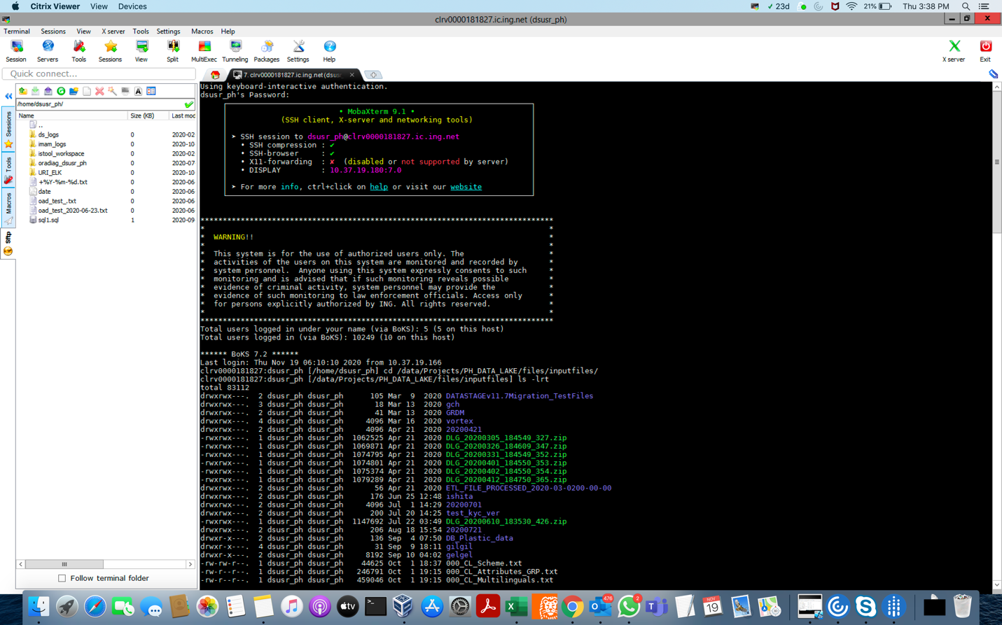

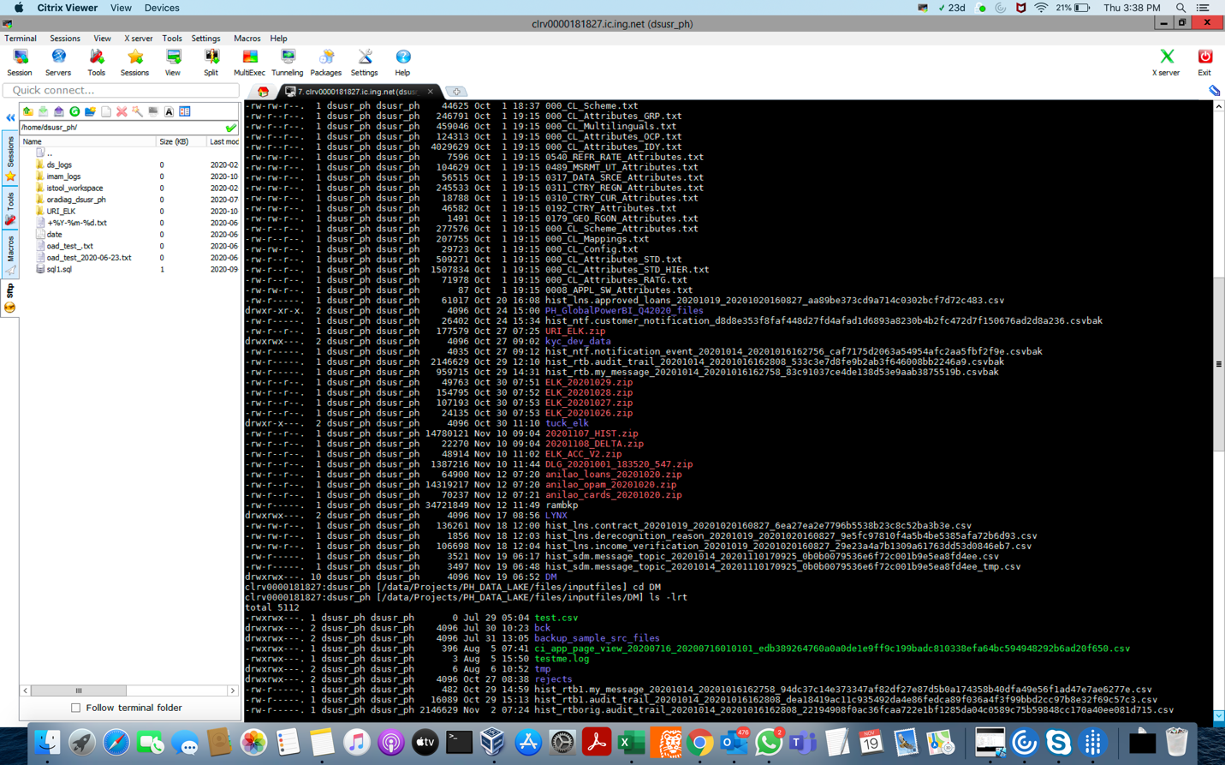

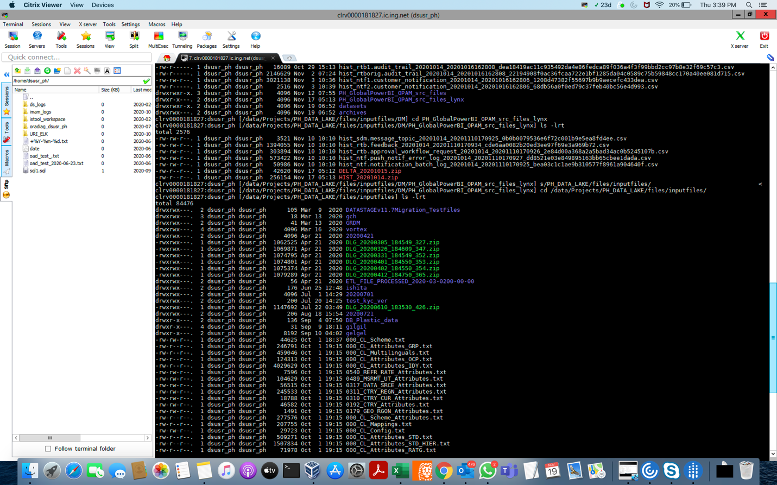

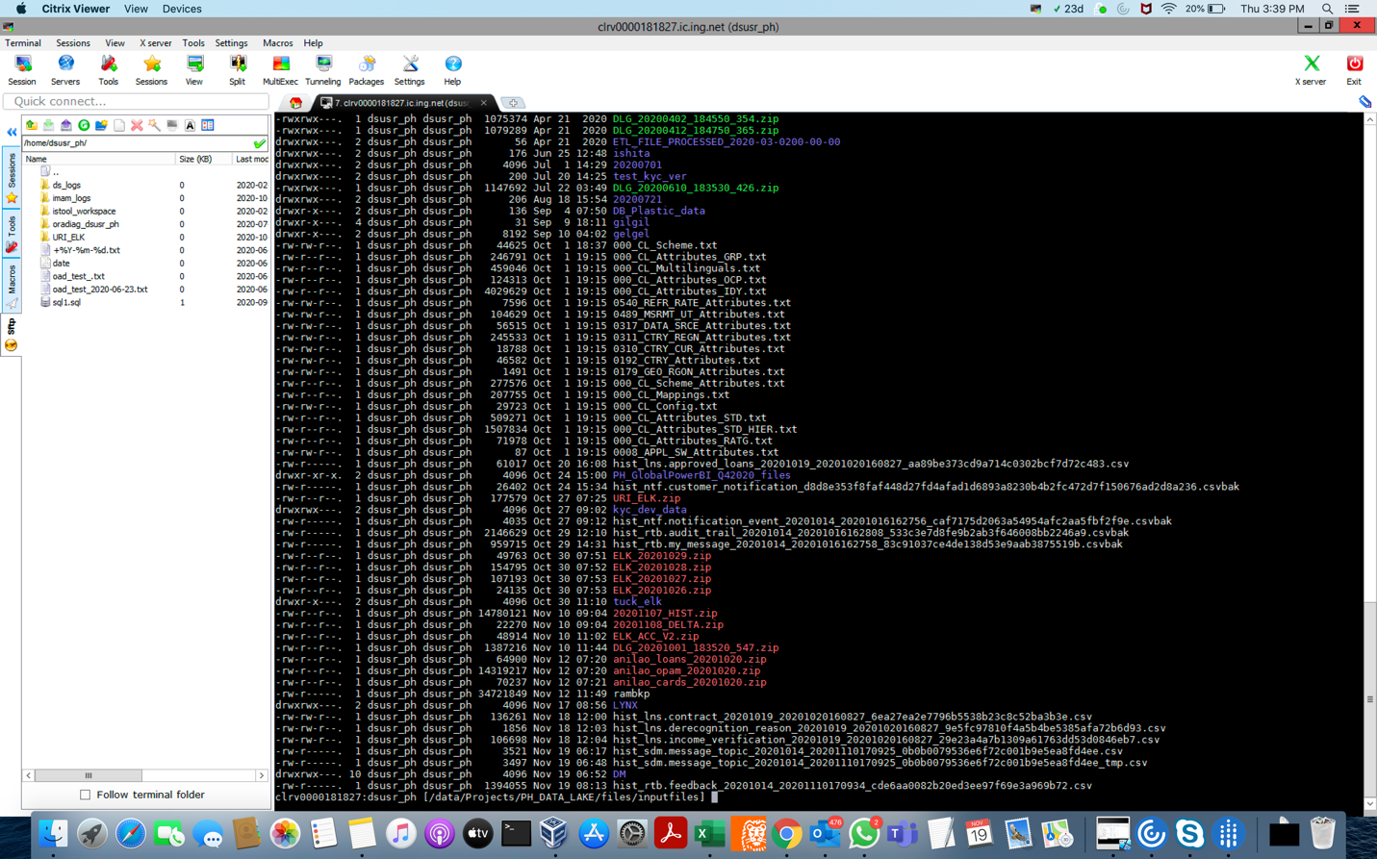

1st dapat PH_OS_STG_ADMIN ang gamit

CREATE TABLE PH_OS_STG_ADMIN.STG_FEEDBACK (

FEEDBACK_ID NUMBER(19,0) NOT NULL,

FEEDBACK_TYPE VARCHAR2(12) NOT NULL,

FEEDBACK_STATUS VARCHAR2(12) ,

DESCRIPTION VARCHAR2(4000) ,

CLASSIFICATION VARCHAR2(4000) ,

REFERENCE VARCHAR2(4000) ,

LOCATION_CODE VARCHAR2(15) ,

CIF VARCHAR2(12) ,

CUSTOMER_NAME VARCHAR2(100) ,

SOURCE VARCHAR2(12) ,

DELETED VARCHAR2(1) ,

COMPLAINT_NBR VARCHAR2(40) ,

UPDATED_DATETIME TIMESTAMP(6) ,

UPDATED_BY VARCHAR2(64) ,

CREATED_DATETIME TIMESTAMP(6) NOT NULL,

CREATED_BY VARCHAR2(64) NOT NULL)

* 2nd for OST (dapat PH_OS_OST_ADMIN and gamit)

CREATE TABLE PH_OS_OST_ADMIN.D2_FEEDBACK_S (

D2_FEEDBACK_S_ID NUMBER(19) NOT NULL

, D2_FEEDBACK_S_SUP_KEY NVARCHAR2(200) NOT NULL

, SRC_STM_CD VARCHAR2(10 BYTE) NOT NULL

, OBJ_TP_CD VARCHAR2(48 BYTE) NOT NULL

, MSTR_SRC_STM_KEY NVARCHAR2(140) NOT NULL

, HASH_VAL CHAR(32 BYTE) NOT NULL

, VLD_FROM_TMS TIMESTAMP NOT NULL

, VLD_TO_TMS TIMESTAMP NOT NULL

, DEL_IN_SRC_STM_F NUMBER(1) NOT NULL

, ISRT_FLOW_RUN_ID NUMBER(19) NOT NULL

, UDT_FLOW_RUN_ID NUMBER(19)

, ISRT_JOB_RUN_ID NUMBER(19) NOT NULL

, UDT_JOB_RUN_ID NUMBER(19)

, ISRT_TMS TIMESTAMP NOT NULL

, UDT_TMS TIMESTAMP

, ID NUMBER(19) NOT NULL

, FEEDBACK_TYPE NVARCHAR2(24) NOT NULL

, FEEDBACK_STATUS NVARCHAR2(24)

, DESCRIPTION VARCHAR2(4000)

, CLASSIFICATION VARCHAR2(4000)

, REFERENCE VARCHAR2(4000)

, LOCATION_CODE NVARCHAR2(30)

, CIF NVARCHAR2(24)

, CUSTOMER_NAME NVARCHAR2(200)

, SOURCE NVARCHAR2(24)

, DELETED NVARCHAR2(2)

, COMPLAINT_NBR NVARCHAR2(80)

, UPDATED_DATETIME TIMESTAMP

, CREATED_DATETIME TIMESTAMP

, UPDATED_BY NVARCHAR2(128)

, CREATED_BY NVARCHAR2(128)

, CONSTRAINT D2_FEEDBACK_S_PK PRIMARY KEY(D2_FEEDBACK_S_ID)

);

COMMENT ON TABLE PH_OS_OST_ADMIN.D2_FEEDBACK_S IS 'Feedback (2020-11-11 - Data Pipeline 2.3.0)';

COMMENT ON COLUMN PH_OS_OST_ADMIN.D2_FEEDBACK_S.D2_FEEDBACK_S_ID IS 'Surrogate Key of table';

COMMENT ON COLUMN PH_OS_OST_ADMIN.D2_FEEDBACK_S.D2_FEEDBACK_S_SUP_KEY IS 'Super Key of table';

COMMENT ON COLUMN PH_OS_OST_ADMIN.D2_FEEDBACK_S.SRC_STM_CD IS 'Source System Code';

COMMENT ON COLUMN PH_OS_OST_ADMIN.D2_FEEDBACK_S.OBJ_TP_CD IS 'Object Type Code';

COMMENT ON COLUMN PH_OS_OST_ADMIN.D2_FEEDBACK_S.MSTR_SRC_STM_KEY IS 'Master Source System Key';

COMMENT ON COLUMN PH_OS_OST_ADMIN.D2_FEEDBACK_S.HASH_VAL IS 'Hash Value';

COMMENT ON COLUMN PH_OS_OST_ADMIN.D2_FEEDBACK_S.VLD_FROM_TMS IS 'Valid From Timestamp';

COMMENT ON COLUMN PH_OS_OST_ADMIN.D2_FEEDBACK_S.VLD_TO_TMS IS 'Valid To Timestamp';

COMMENT ON COLUMN PH_OS_OST_ADMIN.D2_FEEDBACK_S.DEL_IN_SRC_STM_F IS 'Deleted in Source System Flag';

COMMENT ON COLUMN PH_OS_OST_ADMIN.D2_FEEDBACK_S.ISRT_FLOW_RUN_ID IS 'Insert Flow Run Id';

COMMENT ON COLUMN PH_OS_OST_ADMIN.D2_FEEDBACK_S.UDT_FLOW_RUN_ID IS 'Update Flow Run Id';

COMMENT ON COLUMN PH_OS_OST_ADMIN.D2_FEEDBACK_S.ISRT_JOB_RUN_ID IS 'Insert Job Run Id';

COMMENT ON COLUMN PH_OS_OST_ADMIN.D2_FEEDBACK_S.UDT_JOB_RUN_ID IS 'Update Job Run Id';

COMMENT ON COLUMN PH_OS_OST_ADMIN.D2_FEEDBACK_S.ISRT_TMS IS 'Insert Timestamp';

COMMENT ON COLUMN PH_OS_OST_ADMIN.D2_FEEDBACK_S.UDT_TMS IS 'Update Timestamp';

COMMENT ON COLUMN PH_OS_OST_ADMIN.D2_FEEDBACK_S.ID IS 'ID';

COMMENT ON COLUMN PH_OS_OST_ADMIN.D2_FEEDBACK_S.FEEDBACK_TYPE IS 'FEEDBACK_TYPE';

COMMENT ON COLUMN PH_OS_OST_ADMIN.D2_FEEDBACK_S.FEEDBACK_STATUS IS 'FEEDBACK_STATUS';

COMMENT ON COLUMN PH_OS_OST_ADMIN.D2_FEEDBACK_S.DESCRIPTION IS 'DESCRIPTION';

COMMENT ON COLUMN PH_OS_OST_ADMIN.D2_FEEDBACK_S.CLASSIFICATION IS 'CLASSIFICATION';

COMMENT ON COLUMN PH_OS_OST_ADMIN.D2_FEEDBACK_S.REFERENCE IS 'REFERENCE';

COMMENT ON COLUMN PH_OS_OST_ADMIN.D2_FEEDBACK_S.LOCATION_CODE IS 'LOCATION_CODE';

COMMENT ON COLUMN PH_OS_OST_ADMIN.D2_FEEDBACK_S.CIF IS 'CIF';

COMMENT ON COLUMN PH_OS_OST_ADMIN.D2_FEEDBACK_S.CUSTOMER_NAME IS 'CUSTOMER_NAME';

COMMENT ON COLUMN PH_OS_OST_ADMIN.D2_FEEDBACK_S.SOURCE IS 'SOURCE';

COMMENT ON COLUMN PH_OS_OST_ADMIN.D2_FEEDBACK_S.DELETED IS 'DELETED';

COMMENT ON COLUMN PH_OS_OST_ADMIN.D2_FEEDBACK_S.COMPLAINT_NBR IS 'COMPLAINT_NBR';

COMMENT ON COLUMN PH_OS_OST_ADMIN.D2_FEEDBACK_S.UPDATED_DATETIME IS 'UPDATED_DATETIME';

COMMENT ON COLUMN PH_OS_OST_ADMIN.D2_FEEDBACK_S.CREATED_DATETIME IS 'CREATED_DATETIME';

COMMENT ON COLUMN PH_OS_OST_ADMIN.D2_FEEDBACK_S.UPDATED_BY IS 'UPDATED_BY';

COMMENT ON COLUMN PH_OS_OST_ADMIN.D2_FEEDBACK_S.CREATED_BY IS 'CREATED_BY';

CREATE INDEX PH_OS_OST_ADMIN.D2_FEEDBACK_S_I1

ON D2_FEEDBACK_S(D2_FEEDBACK_S_SUP_KEY);

<https://dev.azure.com/retailshelf/rs/_workitems/edit/107806> - release ticket

Sharing: ADO Tickets quick Guide

Detailed info in the link below:

<https://orangesharing.com/pages/viewpage.action?spaceKey=ENG&title=Approval+Process+for+Application+Changes+and+Service+Requests>

=====Release Ticket=====

Creation of Release Ticket c/o Dev - Assigned to: Dev

                  1.) Status => PREP

                - All Related work items such as PBIS/FEATURES/TEST CASES should be linked to the release ticket with correct status)

Pre UAT Approvers

                2.) Status => READY FOR UAT

                - UAT Start PO Approver -> PO/Erika Pena

                - Pre UAT Architect Approval -> Luis/Rix/Architect

                - UAT Start IT End Lead Approver -> Joshua Jorel Lee

         3.) Status => UAT

                - UAT Start test lead approver -> Leix Lei

                - UAT release date

UAT Sign-Off Approvers

                4.) Status => READY FOR PRODUCTION

                - Business Approver - Regina Siy

                - Risk Approver - Regina Siy

                - IT Approver - John Paul Balboa

                - Sign-Off Endorsed By: - Leix Leix/Rechell Libre

UAT Sign-Off Approvers

                  5.) Status => DEPLOYMENT TO PRODUCTION

                - Prod Deployment Approver - John Paul Balboa

                - Release Manager - Engineering Lead/Rotating

                  6.) Status => DEPLOYMENT VERIFICATION

                - Deployment Completed By

                - Actual Production date

                  7.) Status => Done

                - Release Verified By - (Engineer who did not perform the Deployment)

====ESR Ticket====

Creation of ESR Ticket c/o Dev - Assigned to: Devops

                  1.) Status => NEW

                  2.) Status => FOR REVIEW AND APPROVAL

Risk and Impact & Execution Details

                  3.) Status => ASSIGNED FOR EXECUTION

                - Risk Approver - Januar for Opam/Rej for SDL

                - approver - Januar Wayong

                  4.) Status => FOR VERIFICATION

                - Executed By

                  5.) Status => DONE

                - Verified by - (Engineer who did not perform the Deployment)

====Data Request Ticket====

Creation of Data Request Ticket c/o PO/Business/Dev - Assigned to: PO/Business/Dev

                  1.) Status => NEW

                  2.) Status => IN REVIEW

Approvals Tab

                  3.) Status => APPROVED

                - CDO Approver - Regina Siy

                - CIO Approver - Ben Issa/Januar Wayong

                - SCRIPTS ATTACHED make sure the feature/task for the script is linked to the request

                  4.) Status => DONE

                - Executed by

Setup

Hello All,

<https://www.youtube.com/watch?v=MOZMw5_fBFA> - azure devops

Setup environment:

[ ] install git (I am using git in command line) in mac

* Follow steps 5 and 6 of IntelliJ Setup

<https://orangesharing.com/pages/viewpage.action?pageId=88152254>

[ ] install virtualbox

[ ] create windows vm

    https://www.howtogeek.com/657464/how-to-install-a-windows-10-virtualbox-vm-on-macos/

[ ] install visual studio in vm

[ ] install plugin in visual studio

Download and open file using visual studio

https://probitools.gallerycdn.vsassets.io/extensions/probitools/microsoftreportprojectsforvisualstudio/2.6.7/1589401425576/Microsoft.DataTools.ReportingServices.vsix

[ ] configure azure ssh

     Go to <https://dev.azure.com/retailshelf/rs/_git/dba-ingasia-ssrs?path=%2FINGASIA-SSRS&version=GBmaster>

     Select “…” -> clone

     If clone will use https,

         Select “Generate Git Credentials”

         Save password (need nyo to)

    If clone using ssh

        Select Manage SSH keys

        Follow instruction to generate key

[ ] git clone target branch in dba-ingasia-ssrs (in mac)

    Note: Create shared folder in vm para maaccess yung clone from windows

  Clone using https:

  git clone <https://dev.azure.com/retailshelf/rs/_git/dba-ingasia-ssrs>

  Clone using ssh:

  Di ko pa natry 😊

  change branch:

  git branch <target branch name>

  git checkout branch

[ ] create project in visual studio (report server project wizard)

[ ] Add DataSource in project

    Type: Microsoft SQL Server

    Select Build

      [ ] Using devtest DB

          Server name: VM default gateway (example 10.0.0.2)

         Authentication: SQL Server Authentication

        Username: sa

        Password:  super123@BCde

        Note: can access LOANS, CARDS, and ONEPAM database

        Prereq:  execute the following in command line (mac)

For ConsumerLending Devtest: ssh -o "ServerAliveInterval 60" -L 1433:172.23.1.19:1433 <corpkey>@auxl-dmz-fw-1.southeastasia.cloudapp.azure.com -A

      [ ] Using UAT DB

          Server name:

              For UAT1: nonprod-staging-resource-vm0.southeastasia.cloudapp.azure.com

             For UAT4: nonprod-4-resource-vm0.southeastasia.cloudapp.azure.com

          Authentication: SQL Server Authentication

          Username: RPT512CNW

          Password: 123@BCde

            Or

          Username: CDG567JNH

          Password: CardTeam098

           Notes:

* RPT512CNW can only access onepam database
* CDG567JNH can access cards database (not sure if it can access others)

----------------------

Please use the following repository for SSRS reports:

<https://dev.azure.com/retailshelf/rs/_git/dba-ingasia-ssrs>

If need to enhance report but not in above repository,

please check in <https://dev.azure.com/retailshelf/rs/_git/dba-SSRS>

For release/dev branch, please always create in

<https://dev.azure.com/retailshelf/rs/_git/dba-ingasia-ssrs>

To access database in devtest/UAT

* Create whitelist ticket

Sample: <https://dev.azure.com/retailshelf/rs/_workitems/edit/94723>

              Guideline for whitelist: <https://dev.azure.com/retailshelf/rs/_wiki/wikis/rs.wiki/607/Guidelines-for-NSG-Whitelist-Request>

              How to check IP to be used for IP: <https://mgm-poc-portal.southeastasia.cloudapp.azure.com:3000/whatismyip.php>

              Note: Request approval if ticket from Gil per week

* Execute Pipeline for whitelist

<https://dev.azure.com/retailshelf/rs/_build?definitionId=827&_a=summary>

* Request whitelisting approval to Devops in Squad-UAT and DevTest whatsapp group

--------------

Add existing report in visual studio project

* In Solution Explorer, Right click reports
* Select Add
* Select Exisitng item

Add new report in visual studio project

* Right click reports
* Select Add
* Select New item

Add data source to reports

* In report data, Right click data sources
* Select Add Data Source
* Select use shared data source reference

Add Data set to reports

* In report data, right click Datasets
* Select add dataset
* Select Use a dataset embedded in my project
* Select Data source
* Add query
* Select refresh fields
* Select OK

Branching strategy:

<https://orangesharing.com/display/ENG/Branching+Strategy>

Stages of release ticket:

<https://orangesharing.com/pages/viewpage.action?spaceKey=ENG&title=Approval+Process+for+Application+Changes+and+Service+Requests>

Agile WoW 2.0, Flow-Based Development, and Azure DevOps:

<https://orangesharing.com/display/ENG/Agile+WoW+2.0%2C+Flow-Based+Development%2C+and+Azure+DevOps>

<https://dev.azure.com/retailshelf/rs/_releaseProgress?releaseId=10141&_a=release-pipeline-progress> - pipeline na bago

<https://orangesharing.com/pages/viewpage.action?pageId=166759904>

Please inform if you have questions.

You may message me on whatsapp: 09173275047

Regards,

Sam

Megan Sim